Different by One
Age 14 to 16- 1 Star
If you have not used the Cuisenaire Environment before, you might find it helpful to look at the instructions and video before trying this problem.

Choose two different colours of rod, and make a line of each colour.
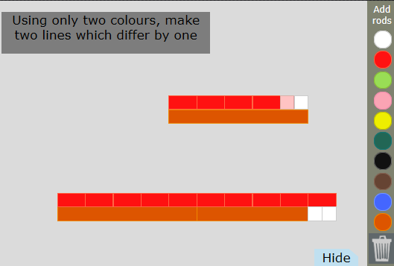
Can you make your two lines differ by the length of one white rod?

