Solution for Rod Fractions

- What fraction is the yellow rod of the orange rod? = 1/2
- Can you find any other pairs of rods so that the length of the shorter rod compared with the longer rod is a fraction with 1 as its numerator?
(Red, Dark Green)
(Red, Light Green)
(Light Green,Dark Green)
(Light Green,Blue)
(Pink,Brown)
(White, Any Colour) 9 possibilities for 10 rods
For n rods, with white as first, we get n-1 rods
- Given an unlimited supply of any two differently coloured rods, can you find a general rule to work out what fraction the shorter rod is of the longer one?
For n number of rods it is 1/n
- Why does your rule work?
This works by placing shirter rods upon longer rods
- can you find a way to express the longer rod as a fraction of the shorter rod?
This can be expressed as “n/1” which is n or n times shorter rod.

By representing like this it is easier to find the answer
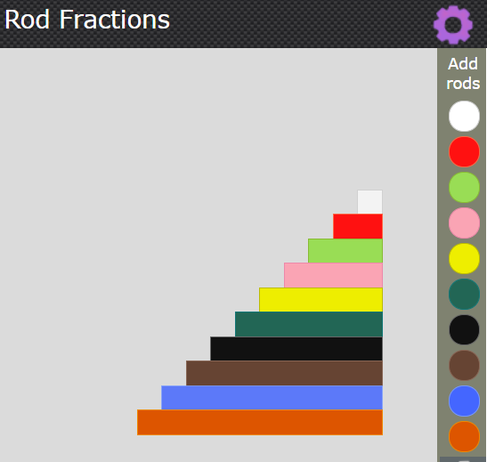
10 white rod length
3 white rod length
3 white rod length
3 white rod length
2 white rod length
2 white rod length
1 white rod length

