Two Clocks
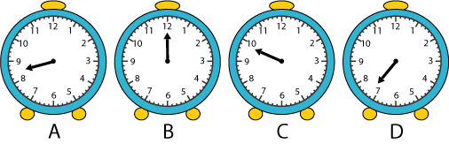
C could be bedtime because ≈9:45am is too late.
D can be when he wakes up because the avg. waking up time is 8:00.
A can be wheŋ he goes to school because he might play before the doors open.
& B is midday because B ≠ 12:00 => B is offset from 12

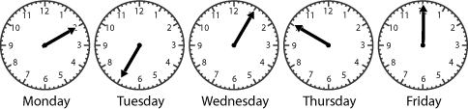
Part 2:
Wednesday could be the day that the teacher kept the class in for 5 minutes because she comes home usually at 4:00 and 4:00 + 5 minutes = 4:05.
Thursday could be the day that she practised in the band because the time just tells us that its XX:50 so it could be 3:50 or 4:50.
Friday could be the day that she hurried straight home because it takes her 30 minutes to get home at least.
Monday can be the day she goes to get sweets.
That leaves Tuseday being the day that she plays with Sam.

