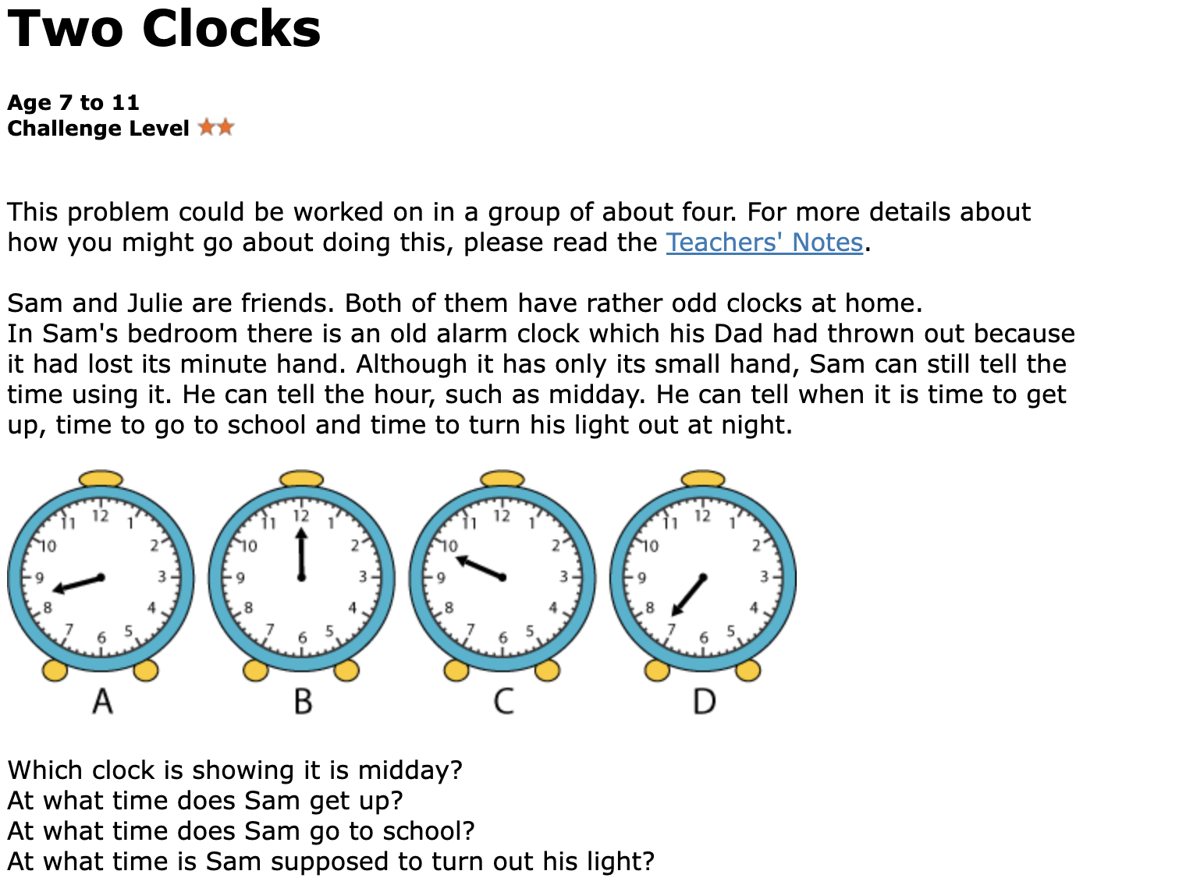

Which clock is showing it is midday? B
At what time does Sam get up? D
At what time does Sam go to school? A
At what time is Sam supposed to turn out his light? C

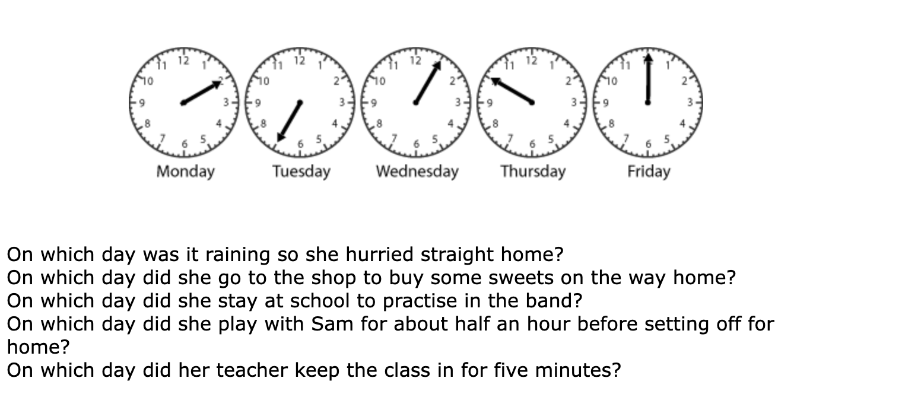

On which day was it raining so she hurried straight home? Friday
On which day did she go to the shop to buy some sweets on the way home? Monday
On which day did she stay at school to practise in the band? Thursday
On which day did she play with Sam for about half an hour before setting off for home? Tuesday
On which day did her teacher keep the class in for five minutes? Wednesday

