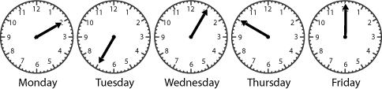
On Wednesday, her teacher kept her class in for 5 minutes so
that must mean that she got there at 4:05 because it takes
her half an hour to get home.So that means she got home at
4:05.

On Friday, she got home at 4:00 because she hurried
Home because it was raining.

On Tuesday, she got home at 4:35 because she was playing with Sam
And she played with him for about 30 minutes but there is no 4:30
So the closest time is 4:35 so I’m assuming 4:35 she got home.

On Monday, she got home at 4:10 because she went shopping for
Sweets so it only takes 10 minutes because it’s only one thing.So that must mean she got
Home at 4:10.

And on Thursday, she got home at 4:50 because she was practicing
Her band which should take around an hour.

