Warmsnug windows http://nrich.maths.org/4889

First we compared the windows I&O because they had the same area but different perimeter and found the price of the frame was £20 per unit. Then we took away the perimeter from the price and found that 1 square unit of pane costs £10.
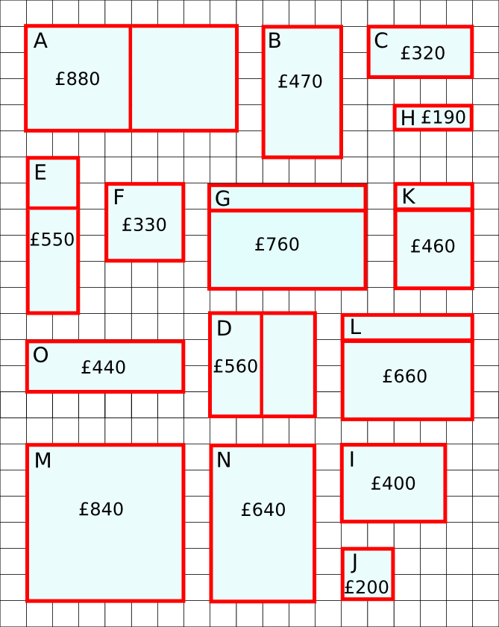
Then we used the unit prices on the windows in turn and found E was the window with the wrong price.

