Product Sudoku
- The boxes adjacent to the cell with the 20 in must be a 4 and a 5, because the numbers must be below 10. 5 cannot go below the cell, because 5 is not a factor of 96, so 4 must go below.
- In the bottom left cell with the number 4, the numbers around it have to be a 2 and a 2 or a 4 and a 1. It can’t be a 2 and a 2, because then they’ll be in the same sub-grid, so it must be 1 and 4. The 1 has to go above the cell and the 4 to the side, because if 4 went above there would be two 4s in that column.
- The numbers around the cell with the 3 in have to be 3, 3 and 1 as there are no other numbers that will make 3. The only possible way for them to be arranged to stop the two 1s being in the same sub-grid or column is a 1 next to the 3 cell, a 1 above the 3 cell and the 3 below the 3 cell.
- Then I thought that the only way of making a product of 30 with three whole numbers less than 10 was 2 x 3 x 5 (I realised later this was wrong). I thought the 5 must go below the cell with the 30 because if it were on either side there would be 2 fives in the same row.
- For the 180 in the left column, the only possible combination without having a number over nine or two numbers in the same column is a 5, a 6 and a 6. We can’t put the 5 to the right of the 180 cell because there is already a 5 in that column, which means a 6 has to go there. Then the other 6 cannot go above the 180 cell, because there would be two 6s in the same sub-grid, which means it has to go below the 180 cell and the 5 above it.
- The prime factorisation of 96 is 2^5 x 3. Since there is already a 4 touching the 96 cell, two of the 2s can be ignored, leaving 2^3 x 3. That can be 8 x 3 or 4 x 6. 4 x 6 is impossible without breaking the rules, so it has to be 8 x 3. 8 isn’t a factor of 324, so the 3 has to go there and the 8 below.
- The prime factorisation of 2835 is 3^4 x 5 x 7. The 5 and 7 have to go by themselves, as if multiplied by anything else they will make a number bigger than nine. That leaves 3^4. The only possible combination from that is a 9 and a 9, otherwise it would have to be a 27 and a 3 which wouldn’t work. The two 9s can’t go in the same bottom left sub-grid, which means one has to go to the right of the 2835 cell. The 7 is then the only number which can go to the left of the 2835 and the other 5 and 9 must go above and below, or vice versa.
- The prime factorisation of 405 is 3^4 x 5. The 405 cell is surrounded by 4 cells, which means it has to be split into 4 factors. The two possible ways are 5 x 3 x 3 x 9 OR… 5 x 9 x 9 x 1. The first set of numbers isn’t possible, because of the surrounding 3s, so it must be the second option. The 1 must go below, because of the 1s in the other rows. One of the 9s must be above the 405 cell, because if they weren’t they’d be in the same row, which is impossible. The other two numbers will fill in later.
- A 9 must go in the middle cell of the middle left sub-grid, because it can’t go in the 3rd column because of the 9 mentioned in paragraph 7 and it can’t go in the 4th row down because of the 9 mentioned in paragraph 8. Also, only a 2 can go in the top middle cell of that sub-grid.
- Then I looked at the top left sub-grid. A 9 must go in the 20 cell, because of the 9 that must go above or below the 2835 cell, in the third column, and the 9 already in the third row.
- The prime factorisation of 36 is 2^2 x 3^2. There can’t be a 1 in any of the boxes adjacent to the 36 cell, because of the 1s in the rows and columns around it. So, our solution excludes a 1. Therefore the 4 numbers must be 2, 2, 3 and 3. The number above the 36 cell must be a 2 as there is already a 3 in that sub-grid. The cell below the 36 cell can’t also have a 2, because it would be in the same column, so it must have a 3. A 2 must go to the right, because there is already a 3 in that sub-grid, so the other 3 must go to the left.
- Then, looking at the 30 cell, I realised it couldn’t have a 2 one side and a 3 the other side as I had thought in paragraph 4, because there is already a 2 and a 3 in the right column. It could have a 1 and a 6 instead, with the 6 on the right because there is already a 1 in that sub-grid.
- The prime factorisation of 600 is 2^3 x 3 x 5^2. The 3 is already there, leaving 2^3 x 5^2. The 5s must be alone, because 5x2 would be too big. So there must be two 5s and an 8. One of the 5s must go above and one to the left, because any other combination would not work. That leaves the 3 on the right.
- Once that is worked out, because of the 5 on the left of the 600, we can tell which way around the 9 and 5 mentioned in paragraph 7 go. The 9 is above and the 5 below. Also, because of the 5 above the 600, we can tell which way around the 5 and 9 mentioned in paragraph 8 go. The 9 is to the left and the 5 to the right.
- From there, I thought it was normal sudoku and that I could fill in the rest of the numbers using the normal rules. I started doing that but I got to something which was impossible to make work and realised I must have made a mistake. I couldn’t find the mistake in the steps I wrote above or the normal sudoku (which I didn’t write down all the steps of). I didn’t have time to keep looking for the mistake, so this is as far as I got.
This is what my grid looked like when I started doing normal sudoku at the end of the steps that I wrote out:
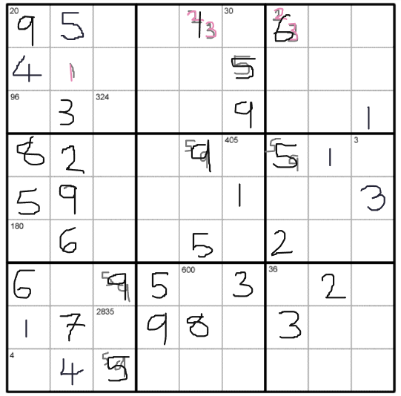
This is what it looked like when I got stuck, when I realised that there was nowhere in the bottom left sub-grid that 3 could go (I used grey for possibilities and black for definites):
