Product Sudoku Solution Nrich

Myself Shubhangee (Facilitator) had worked collaboratively on ‘Product Sudoku’ with a group of 16 students of 3rd to 6th grade, in online mode, in ‘Ganit Kreeda’, Vicharvatika, India. The names of the students are:
Kabir, Arnav P., Arnav B., Nithya, Deethya, Mithravinda, Rivaan, Uday, Udit, Akshobhyan, Srishti, Ruhi, Tejas, Valerie, Nandiinii, Padmini.
Here is the description of our journey.
The cell in the top left corner of this Sudoku contains the number 20. 20 is the product of the digits in the two adjacent cells, which therefore must contain the digits 4 and 5. The 5 cannot go in the cell below the top left-hand corner because 5 is not a factor of 96 (the product shown in the third cell down on the left-hand side of the puzzle). Therefore 5 must be entered into the cell to the right of the cell containing 20 and 4 in the cell below.
Then we solved for 3 and 4. 3 can be written as product of 3 numbers only in 1-way i.e 3 = 3x1x1 and 4 = 1x4 (as 2x2 can’t be used). As there is 4 in leftmost column, 4 will go to the right and 1 will go above the cell containing 4. As two 1’s cannot be written in same box or same column, 3 is written below the cell containing 3.
96 can be written as 96 = 4 x 8 x 3 or 96 = 4 x 6 x 4

I tried to cover our journey in the tabular form. Recording of moves is also done. But, it’s not complete. The entries shown in pitch colour are revisited back. This is the overall flow, where I tried to explain each and every move logically.

Number Clue | Options to factorise | What won’t work | Why | Positions to be eliminated | Final position
20 | 4 x 5 |  |  | The 5 cannot go in the cell below the top left-hand corner because 5 is not a factor of 96 | A2 = 5  B1 = 4
4 | 1x4 |  |  | 4 will not go above the cell as there is already 4 in the column. | I2 = 4  H1= 1
3 | 1x1x3 |  |  | two 1’s cannot be written in same box or same column, so, 3 is written below the cell. | E9 = 3  C9 = 1  D8 = 1
96 | 4x4x6  4x3x8 | 4x4x6 | No place for second 4. | 8 cannot go in the adjacent cell because 8 is not a factor of 324. | C4 = 6  D3 = 3
180 | 9x5x4  6x6x5 | 9x5x4 | No place for 4. | A2=5 F2 = 5 F2 =6  So, E1= 6 E1 = 5 | F2 = 6  G1= 6  E1= 5
2835 | 5x9x9x7 |  | Two 9’s cannot go in one box. | 9 can’t be placed for 2 spots from G3, H2 & I3.  H2 can’t be 5/9. | H4 =9 H2=7
600 | 5x5x8x3  5x5x4x6 |  | Two 5’s is common for both the arrangements. | Two 5’s can’t be placed in a box. Another 5 can’t go in G6(not a factor of 36) or H5(already 5 in a column). | F5=5
405 | 5x9x9x1  5x3x3x9 | There is no place for two 3’s. F2 | One 5 & one 9 is common for both the arrangements. | 1 has only one place as there is already 1 in C9 and C8. To place two 9’s one spot is fixed for 9 i.e C6.  5 cannot go in D5( as F5=5). | E6=1  C6=9  D5=9  D7=5
2835 |  |  |  | As G4 has 5 so, Ge cannot have 5. | G3 = 9  I3 = 5
324 | 4x9x9x1  6x6x3x3  9x2x3x6  3x4x3x9 |  |  | As rows C&D and column3 have already one 9, no place for 9.  As there is 3 in C2, another 3 has only one spot i.e. D3. | D3=3  B3=6  C4=6
30 | 5x3x2  5x6x1 |  |  | 5 is common and it has only one spot i.e B6. | B6 = 5
 |  |  |  | Using rules of normal sudoku. | I1=3  F3=1(4thbox)  E3=4(4thbox)  F1=7(4thbox)  E2=9  D2=2  G2=8(7thbox)  H3=2(7thbox)  B2=1  A1=9(1stBox)  C1=2(1stBox)
36 | 3x2x3x2  3x3x4x1  9x2x2x1  6x3x2x1 | No spot for 1. Can’t place 3 in F7 (already 3 in box). |  | Clashing with 1 in E6, D8, F3 & H1.  Can’t place 3 in G8 and G6 or G8 and H7. | G6=3  H7=3  F7=2  G8=2
30 | 5x3x2  5x6x1 | 5x3x2 | As 7th column has both 2 & 3 | 2nd box has 6 and 3rd box has 1. So, A5 cannot be 6 and A7 cannot be 1. | A5=1  A7=6
600 | 5x5x8x3 |  |  |  | H5=8

Now we can solve remaining sudoku using all rules of normal sudoku.
C8 & H9 = 5 (Completed columnwise)
I4 = 1 (Columnwise) & G7 = 1 (Boxwise)
F4=3, B5=3 and A8 = 3 (Tried to put 3 columnwise and boxwise)
After this we were stuck for longer time. But then instead of writing all possible numbers in each cell, we changed our approach. We just wrote wherever we can write 4 for each box. Then we checked for each column and it was clear that for 7th column there is only one place for 4 which is C7.
Then it was pretty smooth to complete the puzzle.

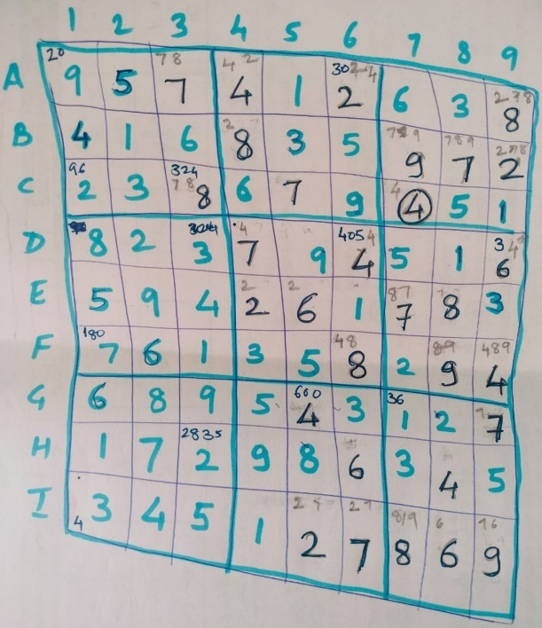
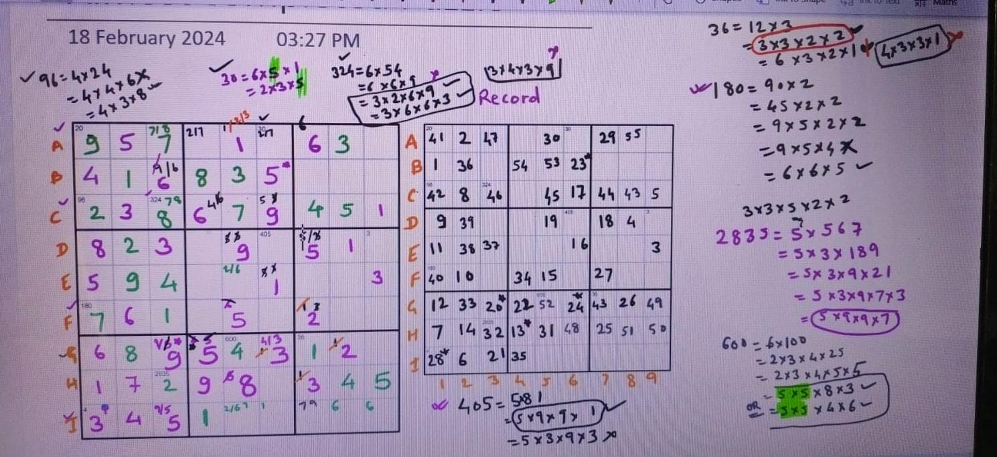
We really enjoyed it. It was easy to start, but became challenging at different points. Every time we tried to solve it; we took different routes.

