Brush Loads
Most - 22 brush loads  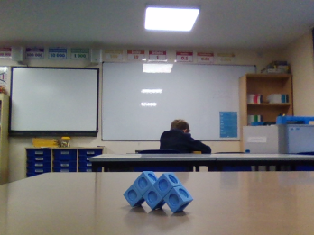 | My trick was to balance it on the corners. Having the most possible faces not touching the table increases the number of brush loads.
21 brush loads  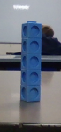 | 20 brush loads  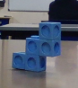
19 brush loads  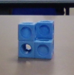 | 18 brush loads  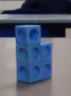
17 brush loads  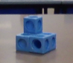 | 16 brush loads  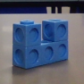
Least - 15 brush loads  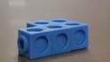 | My trick for this one was to have the most possible faces facing down. Having the most possible faces facing down takes away a lot of brush loads.

