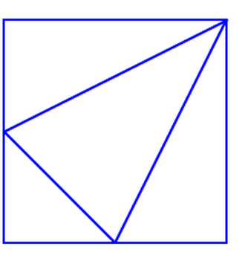

If you consider one side as 8cm, you can solve this problem quite easily.

I split this diagram into quarters:

- 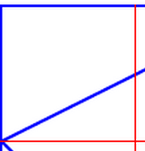
12cm^2
4cm^2
4cm
2cm

The triangle area is 4*2/2, which is 4cm^2.
The whole area is 16cm^2.
The quadratieral area is 16-4, which is 12cm^2.

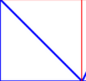

The whole area is 16cm^2.
The triangular area is 16/2 which is 8cm^2.
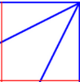
4cm^2
4cm
2cm
8cm^2
4cm
4cm^2
2cm

The triangular area is 4cm^2 each.
Since the whole area is 16cm^2, the quadratiral part will be 8cm^2.
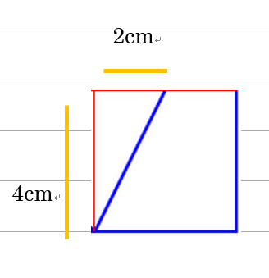
4cm^2

12cm^2

The triangular shape’s area is 4cm^2.
The quadriateral shape’s area is 16-4=12cm^2.

Over all, this is what I think:
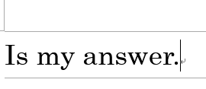
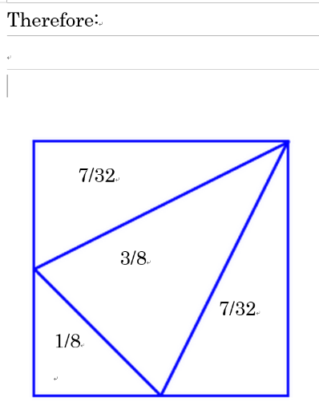
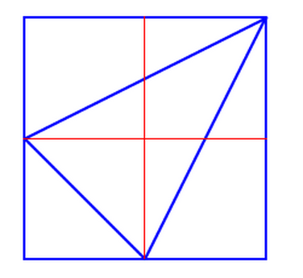
12cm^2
8cm
4cm^2
4cm^2
4cm^2
8cm^2
8cm^2
8cm^2
4cm^2
12cm^2

