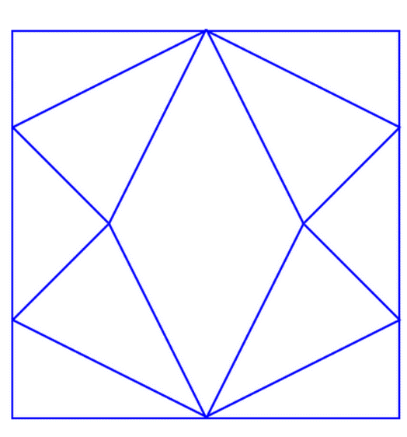
If I consider this diagram’s side as 16cm, I already know that one-quarter of the shape in the middle is 16cm^2. Therefore, the area of the shape in the middle is 64cm^2. The total area is 16*16 which is 256cm^2.
The fraction will be 64/256 which is equivalent to ¼. The answer is one quarter.
The shape in the middle is rhombous.

