Number Sandwiches!
Question 1:


First, I set up the numbers and used trial and error to find a sequence that fit the statement.


Then I tried to find another sequence with the same criteria.


Question 2:


For the next question, I found the answer with the same method using all numbers 1,1,2,2,3,3,4,4.


Question 3:
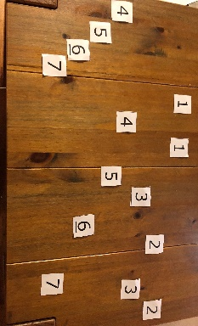
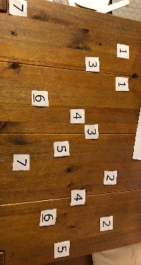
For the final question, I found two answers using the same method using all numbers 1,1,2,2,3,3,4,4,5,5,6,6,7,7

