Roll These Dice
James, Sophie, Rhiannon and Isa (Yrs 5 & 4) from the
Extension Maths Group at St Nicolas CE Junior School, Newbury

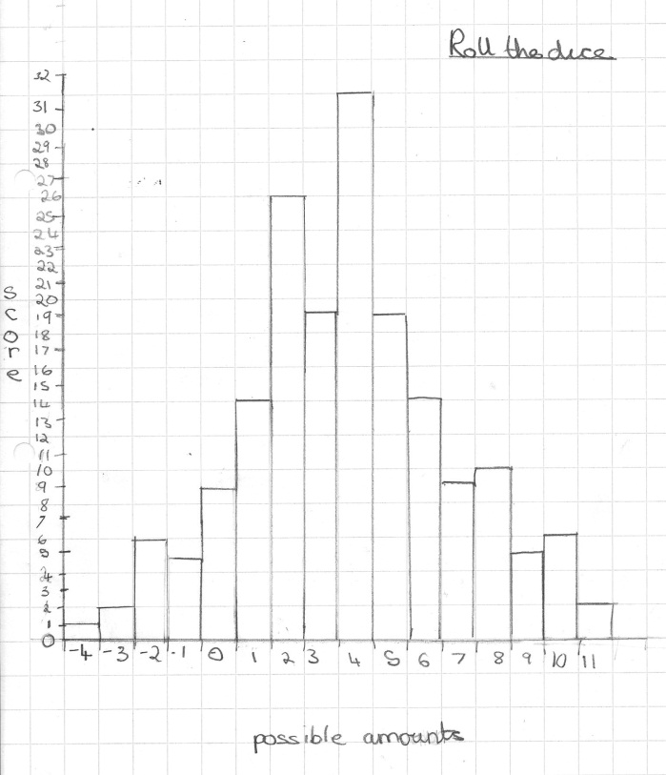
We all started off by rolling the dice to get some results. James noticed that the smallest number you could make is -4 and the biggest is 11. We then put the whole group’s results together so we had a total of 179 rolls. Sophie drew a bar chart to represent this data.

James said that it is hard to get negative numbers because you need to roll low numbers on both dice and then a high number on the other. Rhiannon and Isa noticed that the numbers in the middle had a higher chance of being rolled. This was because there are more ways of making the numbers like 4. You can have 4+1-1, 4+5-5, 4+3-3, 4+6-6, 4+4-4, 5+3-4, 3+2-1, 1+4-1, 4+2-2 and others but there is only one way of rolling -4, 1+1-6, and one way of rolling 11, 6+6-1.

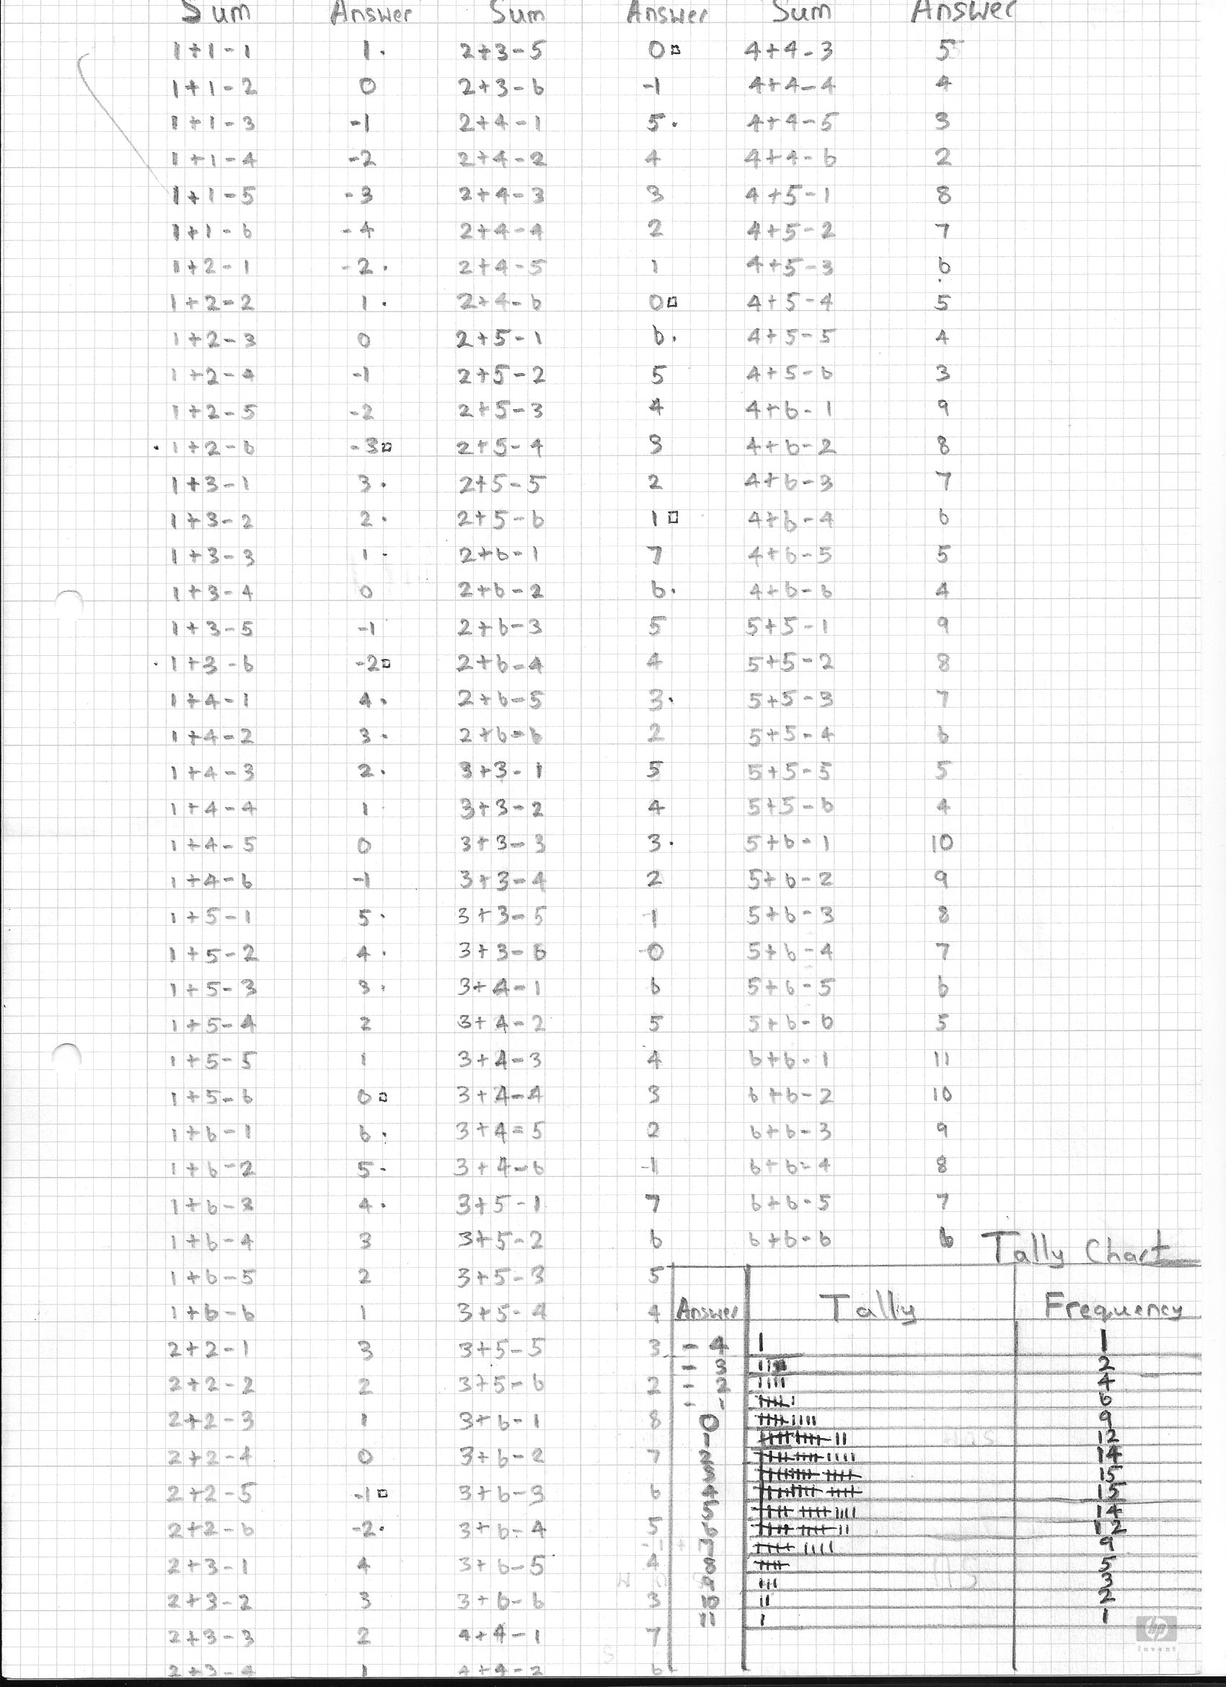
James went on and wrote down all the possible combinations and their results and recorded these in a tally chart (attached). He found that 3 and 4 were the most common answers. He realised afterwards that he hadn’t included all the results because he had only recorded, for example, 1+2-1 and not 2+1-1 as well. He thought he needed to double his answers but then realised that 1+1 is the same as 1+1, so it wasn’t quite double.

