Method in Multiplying Madness

Grid Multiplication: For this method to work you have to partition the numbers that you are working with. For example, 31 x 13, if you partition both of those numbers then the sum looks easier and more approachable. This is exactly the same as column multiplication. The only difference is that grid multiplication is...on a grid! There is a picture attached below of what the grid looks like. This works because it is so much simpler and it looks more approachable than the real numbers.
How long it takes | Around 3 to 4 minutes
How many steps to do it | This takes about 6 or 7 steps including the setting out

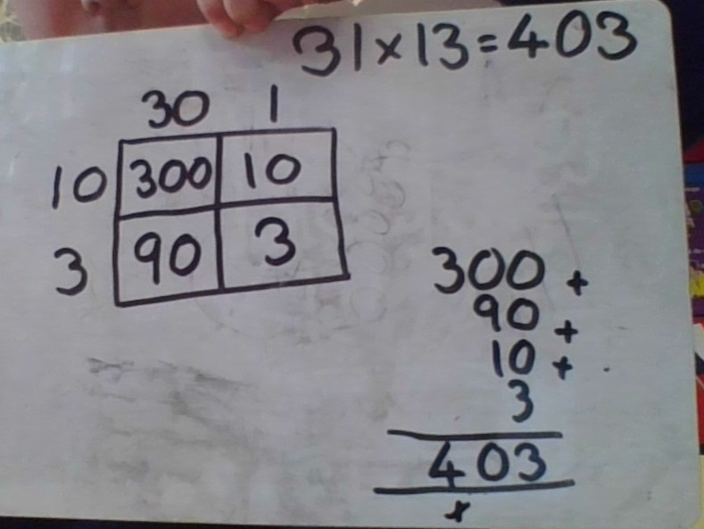

Column Multiplication: This can be very useful for certain numbers but not for others. This is very similar to grid multiplication. It is partitioning the numbers as well, just not showing it. The most important thing is that you have to remember to write the 0 in the second line otherwise the method will not work.
How long it takes | Around 2 or 3 minutes
How many steps to do it | This takes 5 or 6 steps including the setting out

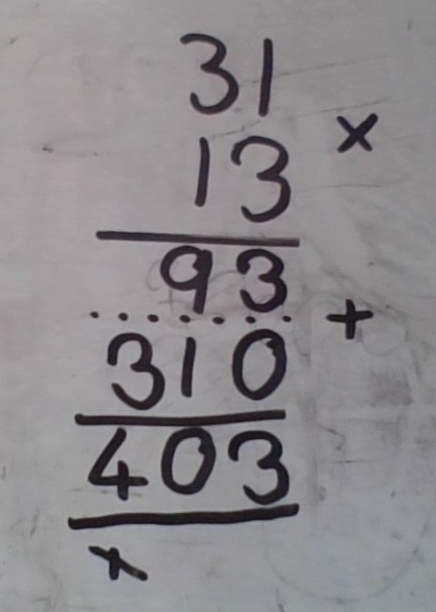

Multiplying with Lines: This is a really clever method. It is also very simple, once you get to know it. To do it you have to draw out lines for each of the digits of the 2 numbers, see the picture below. Then you have to draw two dotted lines, as shown, separating the bottom corner from the middle two corners and the top corner from them as well. After this you have to add up all of the places where the lines are perpendicular and make a corner. But you must remember to only add them up on their side of the dotted lines. The numbers that you get are the digits of your product, shown in the order below.
How long it takes | Around 5 minutes
How many steps to do it | This takes about 7 steps including the setting out
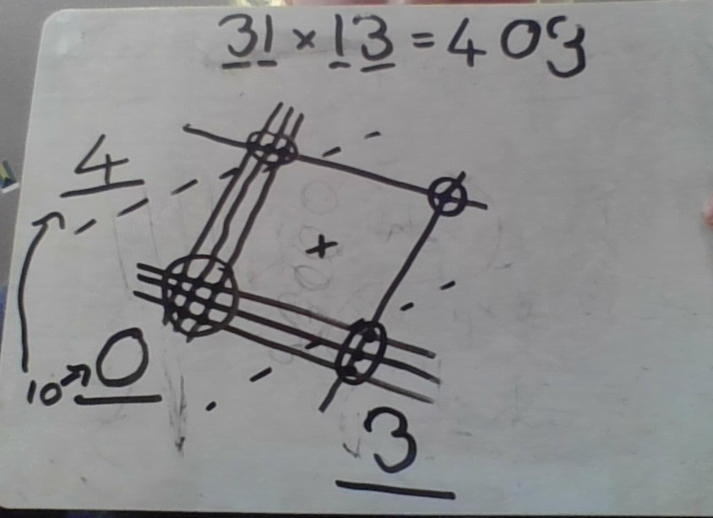

Gelosia Multiplication: This is set out in a sort of grid, only slightly different to grid multiplication. Unlike grid multiplication this method doesn’t partition the numbers, it only takes the digits and puts them in the correct spaces. You then need to times the numbers like you do in grid multiplication and write them in the boxes. The diagonal block lines are only for if you have a 2 digit number as your answers in the boxes. Then write in the dotted diagonal lines and add up the numbers on their side of the dotted lines. Wait, that’s rather like multiplying with lines! Again, as you can see in the picture the 10 that you get from adding 9 to 1 has to be split up and the 1 has to be added to the 3.
How long it takes | Around 3 to 5 minutes
How many steps to do it | There are about 6 steps including the setting out
