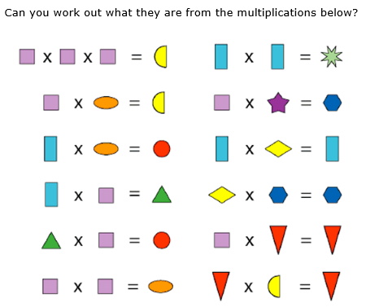
Explanation
First, we looked at the two in the bottom right corner and discovered that it was 0 since when it was multiplied with the other shape it became itself, and the only number that can do that with is 0 or 1. We made the rhombus 0. So, we realized that the rhombus had to be a 1 since it couldn’t be a 0. Then we looked at the squares and guessed that it was 2. So, then we know the semicircle would then have to be 8. Then if the semicircle was 8 and the square was two then the oval would be 4. We made a guess that the rectangle was a 3. So, if it was a 3, then the triangle would be 6. And if the triangle was 6 then the circle would be 12. Then if the rectangle was 3 then the 8 sided-star would be 9. Then the only numbers left were 5, 10, 7, and 11. The problem with the star and the hexagon it is being multiplied by two so the only ones that were doubles were 5 & 10. That is how we figured out the number each shape was.
Key:
0 =

1 =
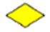
2 =
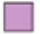
3 =

4 =
5 =

6 =
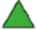
8 =
9 =

10 =

12 =


