Solutions
Can you tell the order of the cards?
I started by taking a set of thirteen cards like in the video. Then I drew a cart that looks like this:
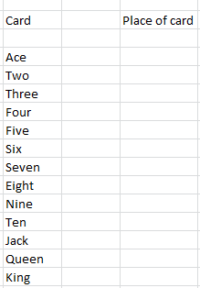
Then I tried to figure out the order of the cards in the trick by looking at the video repeatedly. This is the result that I got;
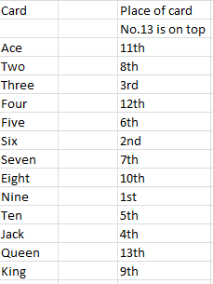
Therefore, the order goes like this:
Queen,4,1,8,King,2,7,5,10,Jack,3,6,9
Can you perform the trick?
Yes, I can. I used the table above to help me.
Can you perform it in a different language?
No, I tried to do it in French, but it did not work.
I am guessing that it will work in anther order.

