T is for Tan
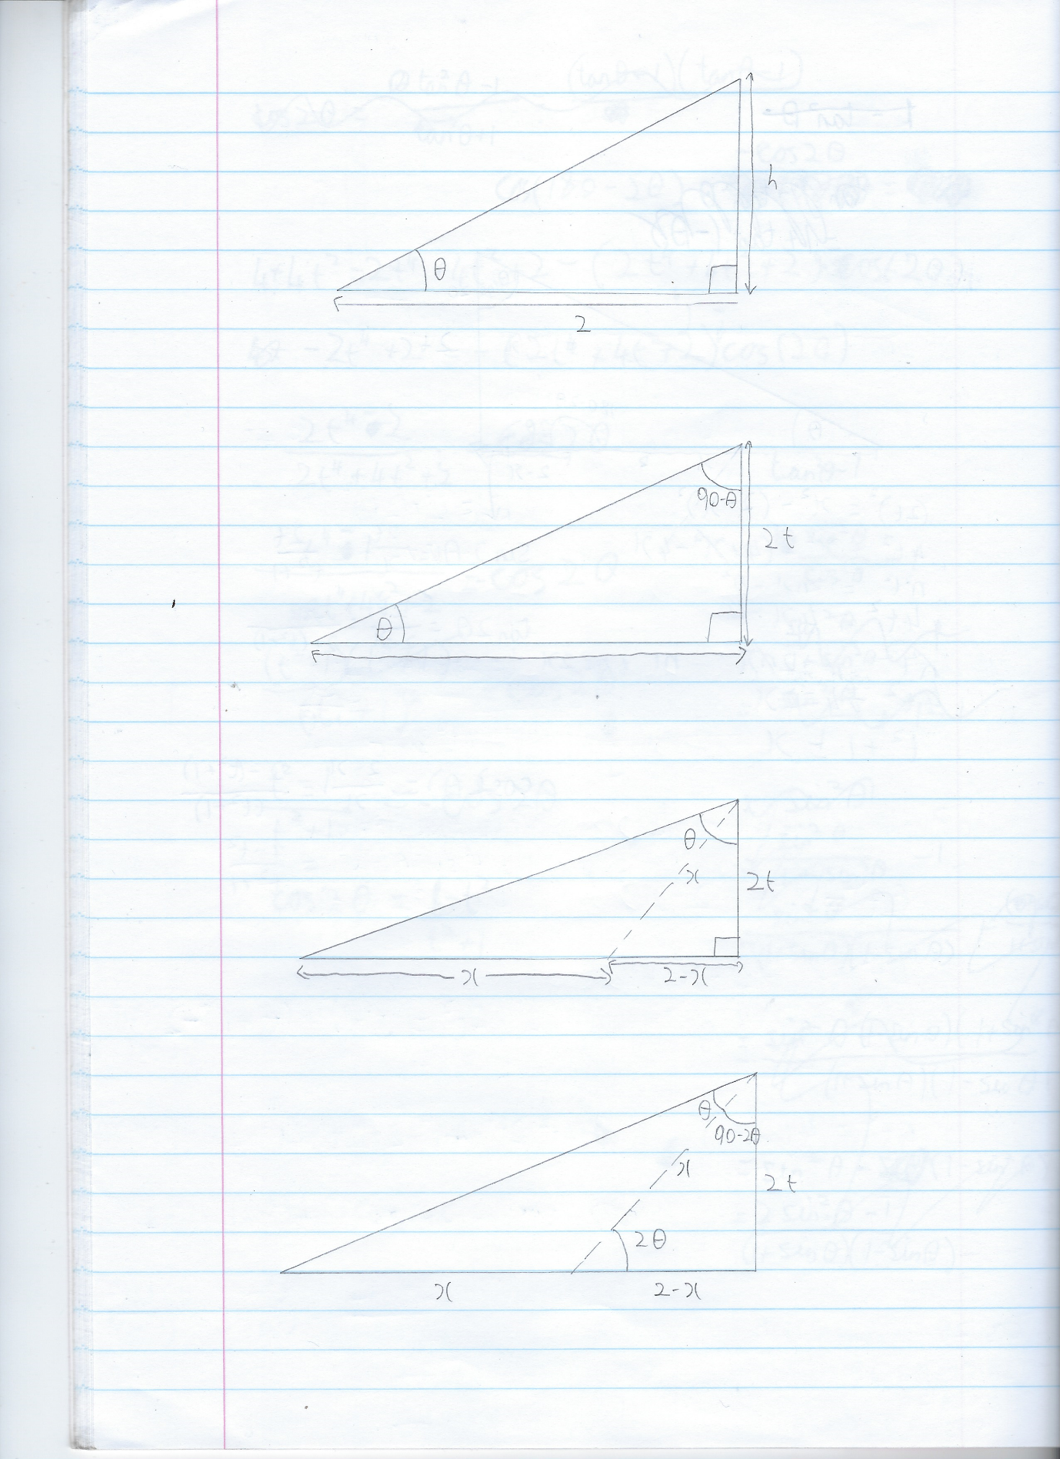
Firstly, to find the height of the triangle in terms of t, where t = tanθ.
Whenever I look at a right-angled triangle it instantly makes me think: Pythagoras and trigonometry. Since we have a side and angle, and we want the unknown in terms of tanθ, it makes most sense to use trig here.
We want to find the opposite angle in terms of tan θ, so using SOHCAHTOA we can use Opposite = tanθ × Adjacent
Subbing in t = tanθ in and 2 as the value of our adjacent side.
We get h = 2t.
Briefly, before we draw the line down the centre to form our isosceles triangle, if we look at the angle in the top right of the triangle, we can label that 90- θ as we know that in Euclidian geometry all angles in a triangle add up to 180° and we know that the other angles in the triangle are θ and 90° hence this angle is 180-90- θ = 90 - θ° (or π/2 – θ radians if you’re more inclined that way)
Now the line is drawn such that an isosceles triangle is formed with 2 sides of length x and 2 angles of θ.
Before we attempt to prove our double angle formula straight away, it is always useful to reduce the number of variables at play, so here we will attempt to find x also in terms of t. Notice that alongside the isosceles triangle that has been formed, a new right-angled triangle has been formed with sides x, 2t and (2-x). Since it is 3 sides that we are looking at, pythag makes the most sense to use here.
Rearranging a² + b² = c² to b² = c² – a² and then substituting our sides in gives us:
(2t )² = x² - (2-x )²
Expanding gives us:
4t² = x² - 4 - x² +4x
Which simplifies to:
4t² +4 = 4x
Dividing through by 4:
t² +1= x
Finally, the last thing we need before we can prove our double angle formula is an angle of 2θ to work with.
If we remember that previously we have shown that the top right angle of the large triangle was 90 - θ°, we can easily see that since we have cut the angle into 2 with one angle being θ the other angle must be 90 - 2θ.
From here we can see that the smaller triangle has an angle of 2θ due to all angles adding to 180° in a triangle:
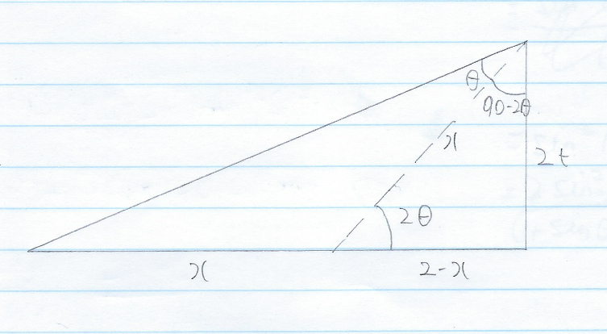
180 - (90 - 2θ) - 90 = 2θ

Now we have everything we need to put tan 2θ, sin 2θ and cos 2θ in terms of t.
Firstly, for tan2θ we can use $tan θ =\frac{opposite}{adjacent}$:
$tan2θ =\frac{2t}{2-x}$
Now substituting in x = t² +1:
$tan2θ = \frac{2t}{2-(t^{2}+1)}$
Therefore:
$tan2θ =\frac{2t}{1-t^{2}}$ As required.

Secondly for sin2θ we can use $\sin{θ}=\frac{opposite}{adjacent}$:
$sin2θ =\frac{2t}{x}$
Again, substituting in x = t² +1:
$sin2θ=\frac{2t}{t^{2}+1}$ As required.

Finally, for cos2θ we can use $cos θ =\frac{adjacent}{hypoteneuse}$ :
$cos2θ = \frac{2-x}{x}$
Subbing in for x = t² +1:
$cos2θ = \frac{2-(t^{2}+1)}{t^{2}+1}$
Therefore:
$cos2θ =\frac{1-t^{2}}{1+t^{2}}$As Required.

