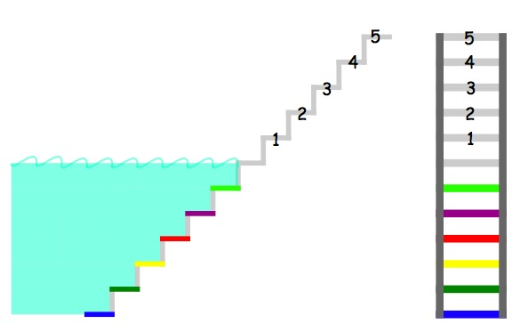
Answers
- If you go down from step 4 to step red , you would of walked down 7 steps.
- If you go down from step 2 to step blue you would of walked 8 steps.
- If you go up from the ground then to step yellow then to step 5 you would of walked 12 steps.

By Ciara , Hotwells primary school

