nrich math challenge: connect 3
By Nevio Carta

In this paper, I will be explaining my solution to the connect 3 nrich math challenge. To recognize the 2 different spinners, the one with the numbers 1,2,3,-4,-5,-6 will be called spinner A, and the other, (with the numbers -1,-2,-3,4,5,6) will be called spinner B. First of all, to explain the question about the different amount of combinations for each number, I have created some tables to help explain.

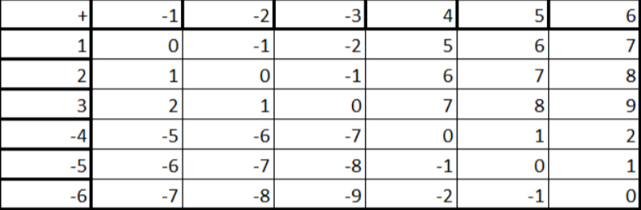
The first table has what happens when you add the 2 numbers together. When adding, you can arrange the numbers in any order and get the same result, that is why we have only 1 table for addition. A+B=C, B+A=C

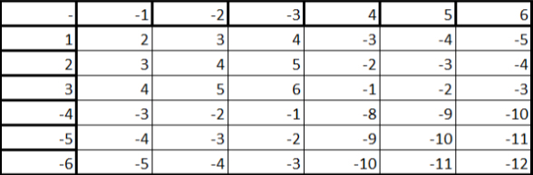
The second table has what happens when you subtract spinner B from spinner A.

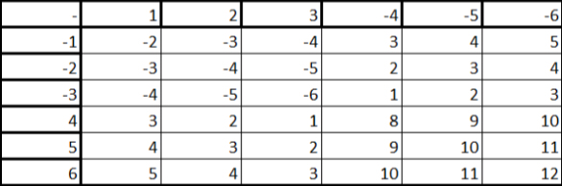
The final table is what happens when you subtract spinner A from spinner B.

There are 2 tables for subtraction because you cannot reverse subtraction and get the same answer. A-B=C, B-A=-C. One result of this is that one table is the exact same as the other table except for the fact that every positive number is switched for a negative number and every negative number is switched for a positive number.

Layout of tables
Let’s start by looking at the layout of each table and what patterns there are.

Each table can be split int 4 quarters and in each quarter the numbers are in the the same range.

Let’s start with the adding table. The first quarter in the top left has only numbers from -2 to 2, averaging 0. This is the same in the bottom right. This happens when you are adding 2 numbers from the first 3 numbers on each spinner or when you are adding a number from the last 3 numbers on 1 spinner to the last 3 numbers on the other spinner. In the case of the top left quarter, we are adding 1,2, and 3, to -1,-2, and-3. In the case of the bottom right, we are adding 4,5, and 6, to -4,-5, and -6. In the bottom left and the top right, we have the the numbers -5,-6,-7,-8,-9, and the numbers 5,6,7,8, and 9. These are created when you add the first 3 numbers of 1 spinner, to the last 3 numbers on the other spinner. Now lets talk about the subtraction tables. Because both of the subtraction tables are the same except that each negative number is switched for a positive number and each positive number is switched for a negative number, I will only talk about one of the tables, the first one. In the subtraction tables, the top left quarter is different from the other quarters, if it has positive numbers, all the other quarters have negative numbers. It is the exact opposite for the other table
. In the top left quarter, you have the numbers from 2-6. They are created by subtracting one of the first three numbers in spinner B from one of the first three numbers in spinner A. In the top right and bottom left quarters, the numbers are the exact same so I only need to talk about 1. They have the numbers from -1 to -5 and are created when you subtract one of the last 3 numbers from spinner B from one of the first 3 numbers from spinner A ( true only for top left, top right is 1st 3 numbers from B and last 3 from A). The bottom right quarter has the numbers from 8-12. This is the only time the numbers from -10 to -12 appear, and they are created by subtracting the last 3 numbers from spinner B from the last 3 numbers of spinner A.

Combinations per number and tactics during the game
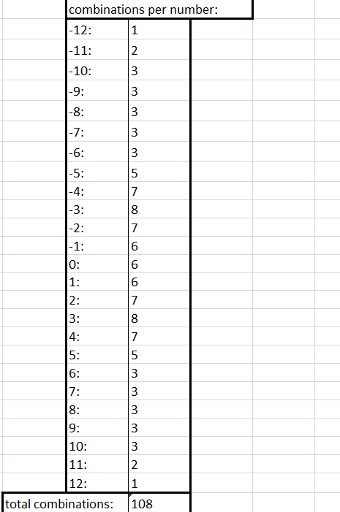
Now, I have a table that shows the number of combinations per number.
The total combinations is 108. This matches what there should be based on the graphs because there are 3 graphs each with 36 combinations making a total of 108 combinations. The numbers with the largest amount of combinations are the numbers -5 to 5 with the highest being -3 and 3 with 8 combinations. If you are playing the game, these are the numbers you want to use because there is the highest probability of you getting your 3 in a row before your opponent. Let’s have a look at the playing board to see what the easiest ways to get 3 in a row would be.
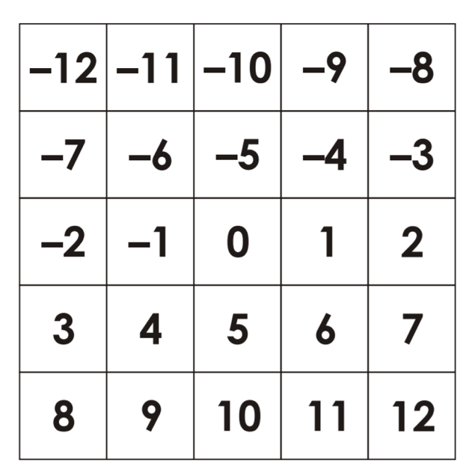
The easiest ways to get 3 in a row include all the ways that go from the row above the middle, to the row in the middle, to the row bellow the middle. Also, 3,4,5 is easy, -3,-4,-5 is also easy, so is anything that has all 3 numbers along the middle. The problem with these possibilities is that they are also the easiest for the opponent to block. However, this is made up for by the fact that there are so many easy ways to get connect 3 in that area of the board that if one is blocked, you have lots of others you can do where you already have at least 1 piece in place for them. If you are trying to block someone else, the easiest way is to take up all the easiest to reach places around it because it is hard to tech numbers like 6,7,8, and 9, and their negative counterparts and even harder to reach 10,11,12, and their negative counterparts

