Suppose that in a bag of marbles, all the ones that -

are rough to feel, have a blue colour on them;

sparkle when rolling, have a red colour on them;

are cold to touch, have a white colour on them;

are dark inside, have a green colour on them.

What can you say about each of the marbles A - J?
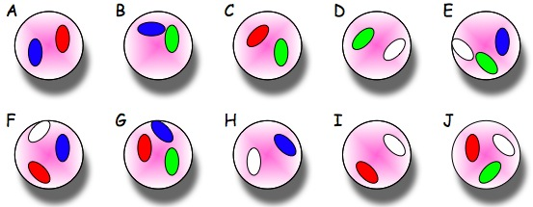
A: is rough to feel and sparkles when rolling
B: is rough to feel and is dark inside
C: Sparkles when rolling and is dark inside
D: is dark inside and is cold to touch
E: is dark inside, rough to touch and cold to touch
F: cold to touch, rough to touch and sparkles when rolling
G: dark inside, sparkles when rolling and rough to touch
H: cold to touch and rough to touch
I: cold to touch and sparkles when rolled
J:dark on inside, cold to touch and sparkles when rolled
Imagine you are making marbles. What colours must be put on marbles that -

sparkle when rolling but are dark inside? Red and green

are cold to touch and feel rough? Blue and white

are cold, but sparkle when rolling? White and red
What colour(s) could be on a marble that -
is cold? white

sparkles when rolling? red
What colours would you find on a cold, sparkly, dark and rough marble?
Red, blue, white, and green

