Rabbits in the Pen

Stage:2 Challenge Level:

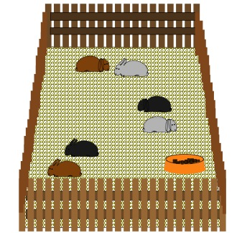
Question 1
How many, and of what kind, will there be in a pen if all these statements are true?
- There are more brown than any other colour
- There are equal numbers of floppy browns and ordinary browns
- There are three which have floppy ears
- There are twice as many floppy browns as floppy whites
- There are three times as many blacks as whites
There are:
- 4 browns all together
- 2 brown rabbits with floppy ears
- 1 white rabbit with floppy ears
- 2 ordinary brown rabbits
- 3 black rabbits

To start with we found out that there were 3 floppy eared rabbits, there were also twice floppy browns as there are floppy whites, so we worked out that there are 2 floppy browns and 1 floppy white. There were equal amounts of floppy browns as ordinary browns so as there are 2 ordinary browns there are 2 floppy browns. Because there are 3 times as many blacks as whites there are 3 blacks and 1 white. There are 8 rabbits altogether.

Question 2
How many, and of what kind, will there be in the second shop if all these statements are true?
- There are the same number of blacks as browns
- There are twice as many floppy browns as ordinary browns
- There are the same number of floppy browns as floppy greys
- All but one are floppy

There are:
- 1 ordinary brown rabbit
- 3 black rabbit with floppy ears
- 2 brown rabbits with floppy ears
- 2 grey rabbits with floppy ears

To start with we knew that there was only 1 ordinary rabbit and that there are twice the amount of floppy browns than ordinary brown rabbits meaning that there are 2 floppy brown rabbits and one ordinary. There is the same number of floppy browns as floppy greys meaning that there are 2 floppy greys. There is 3 browns so there is also 3 black.
By Helena, Finley and Frederica from Hotwells Primary School.

