Simultaneous Equations Sudoku Abhinav Tavva 02/07/2022
- Using the 4th row and 4th column, we can deduce the value of g due to the mutual variables of m, k and c which sum to 16 (4th column) to calculate the value of g by subtracting 16 from 23 to give g = 7.
- Using the knowledge of g being 7, we can calculate the value of c + k being 10, using the first column, as 17 -7 = 10. Then, via column 4, we can find m by subtracting 10 from 16, hence m = 6.
- On the 5th row, p + g = 11, so p is 11 – 7, meaning p = 4.
- On the 5th column, using the fact that p is 4, e must be 5 - 4, so e = 1.
- Now that we know the value of e, we can figure out f, as e + f = 10 (2nd row), and so f is 10 – 1, making f = 9.

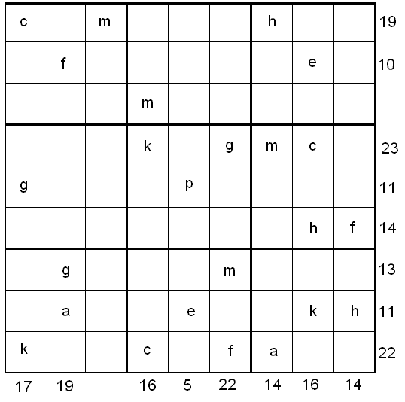
- Since f is 9, h must be 14 – 9, using the 6th row, meaning that h = 5.
- Via the 9th row, using our previous knowledge of k + c = 10 (step 2), and f = 9, a is 22 – 19, so a = 3.
- Due to a being 3, e being 1 and h being 5, we can deduce, using the 8th row, that k is 11 – 9, therefore, k = 2.
- Finally, using the fact that c + k is equal to 10 (found in step 2), and that k is 2, c must be 10 – 2, thus c = 8.

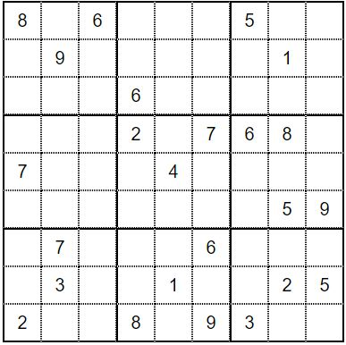

Now that we have calculated all of the values of the 9 variables, we can fill out the sudoku table like so:

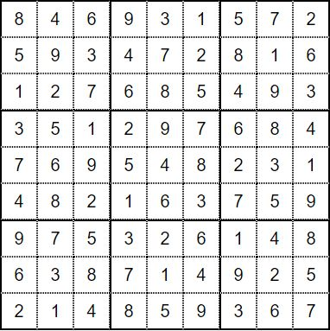

By replacing the letters, the remaining squares are worked out via the typical sudoku strategy, leaving us with this complete sudoku:

