Students Solution to Find the Difference
We collaboratively worked on a new live task ‘Find the Difference’ from Nrich. Vansh, Eshaan, Vraj, Rishaan, Samaira, Renah, Udit, Uday, Viha, Gowri, Arya, Krishna, Rivaan, Miraya and Hiren from Ganit Kreeda, Vicharvatika, India worked together with Shubhangee in 3 sessions to find out different solutions.

- Kids were divided into 4 groups and each group worked independently in the breakout rooms.
All the teams found 2 or more correct solutions. We discussed the method and listed down their observations in the main session.
Here are 4 different solutions discussed in the session:

We referred to this pic while discussing:

Observations discussed during the first session:
- 6 cannot go in the topmost two rows as 6 being the biggest number it is not possible to find 2 numbers from 1 to 6 whose difference is 6. That means 6 can occupy only boxes in the bottom row.
- 5 cannot come at the topmost layer as we cannot use 6 in the second row.
- 4 cannot come at the topmost square as the only way to get 4 is by 5-1 in the 2nd row. To get 5 in the second row, the only way is 6-1. As we cannot repeat the numbers (1), we cannot use 4 at the top.
- Only smallest 3 numbers (first 3 numbers) can come at the top.
- Rishaan noticed about numbers at A and E that one is factor/multiple of other.
- He also noticed that either A+B+D = 9 or A+C+F = 9.
If A+C+F =9 then B+D+E = 12 as 1+2+3+4+5+6 = 21 and same is true in other case.
Based on our observations we made a table as follows:

 | 1 | 2 | 3 | 4 | 5 | 6
A
B
C
D
E
F

Samaira explained why there cannot exist any other solution using algebra as shown: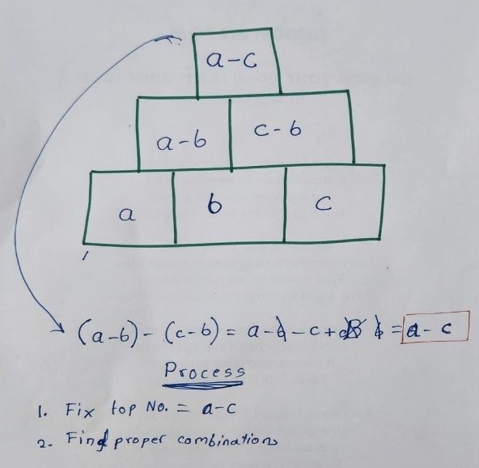 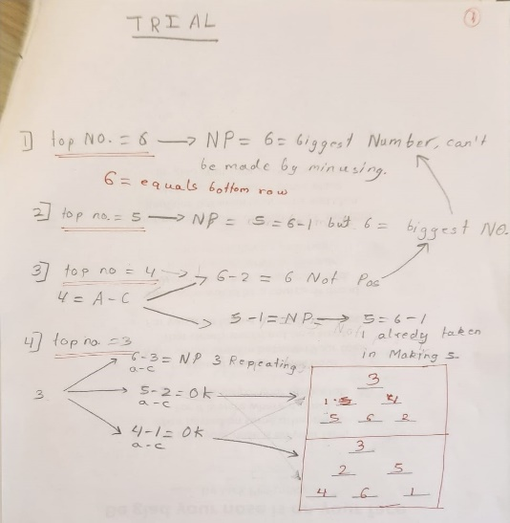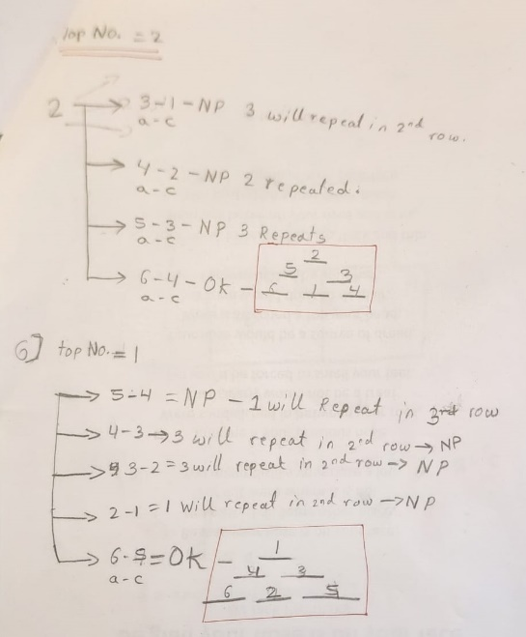

Samira’s approach has one problem which was pointed out by Vansh. He said that how can we say that b is always smaller than a and c (refer to first pic).
Rishaan explained it then using different strategy:
Only smallest 3 numbers i.e. 1, 2, 3 can come in the topmost square. So, he listed down all the possible ways to write 1, 2 and 3.
Top Row No. | 1 | 2 | 3
Diff Ways | 6-5  5-4  4-3  3-2  2-1 | 6-4  5-3  4-2  3-1 | 6-3  5-2  4-1
Then he eliminated all pairs with 6 as 6 cannot come in the second row. Some cases were eliminated as duplication of numbers were not allowed.
All other cases were checked by plugging the numbers and finally we got above listed 4 solutions.

Rishaan’s work is shared here as it is:
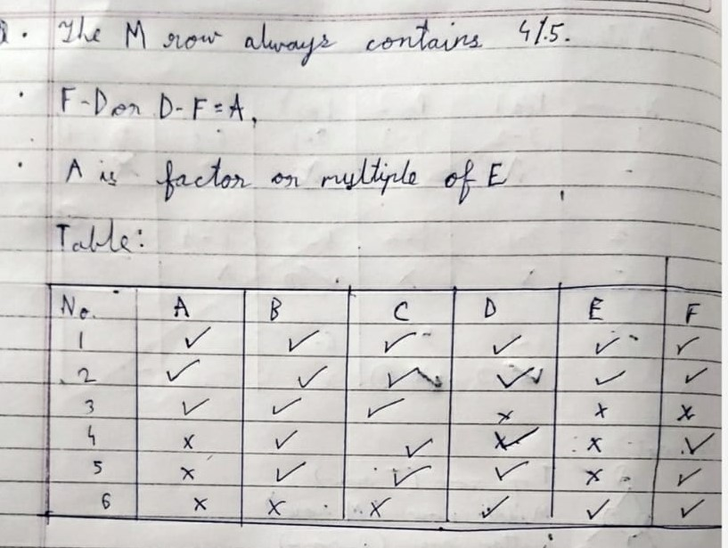

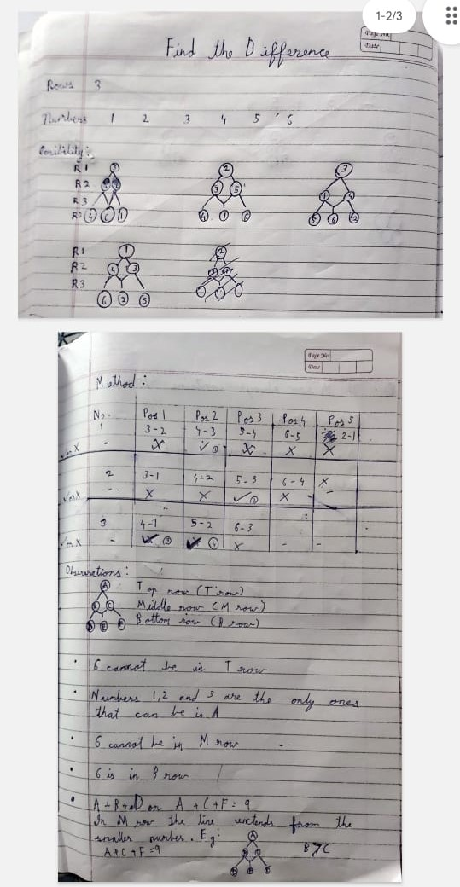

Then kids were asked to work with 4-layer pyramid with 1-10 numbers. Before this, kids analysed the solution from 3-Layer pyramid with 3 at the top.

They noticed that by changing the positions of 1 and 4 with 5 and 2, we can get these 2 different solutions.
We used Samaira’s method as explained earlier.
Rishaan beautifully explained the reason.
4-1 = 5-2 = 3….so we can change their positions.
Also, 1+5=6 or 6-1=5 & 6-5=1 and 6-4=2 & 6-2=4
We can change their relative positions.
In short, try to find out 2 pairs whose difference is topmost number (3 in this case) and middle number (i.e. 6) is sum of one number from each pair.

They come up with following 4 solutions:
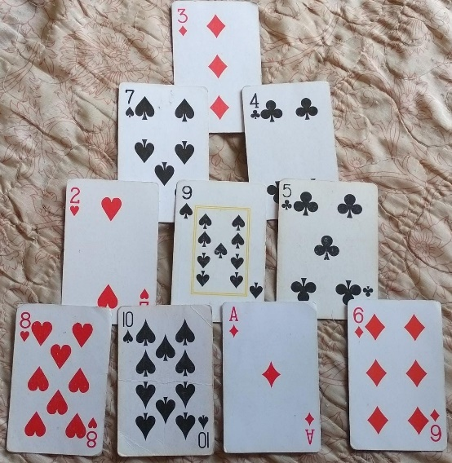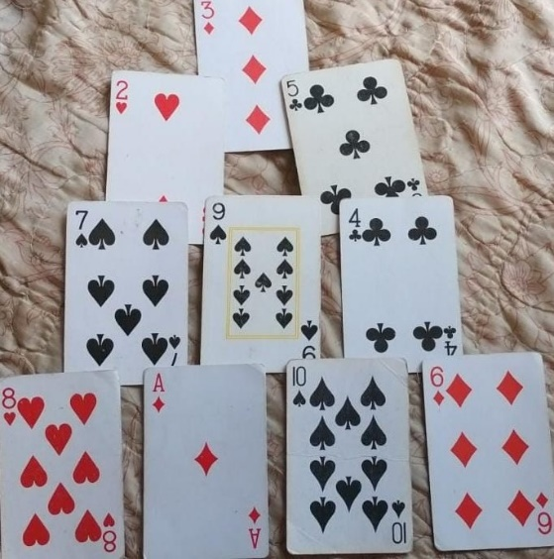

What we observed that by changing the positions of 7 and 4 with 2 and 5, we can get these 2 different solutions.
We used Samaira’s method as explained earlier.Similarly, by changing the positions of 5 and 1 with 2 and 6, we can get following 2 different solutions.
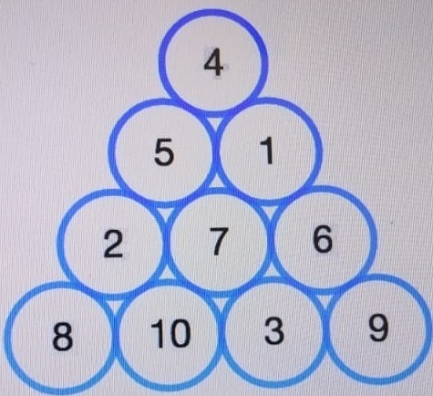
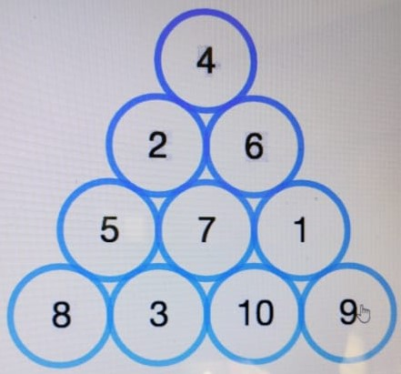
Then we thought of few questions:
- What if we use some other set of 6 consecutive numbers, will this logic work?
We tried but it didn’t.
- Then I asked them one question, if we send this pyramid into number machine and we get a new subtraction pyramid with all different numbers. Can we find the operation, machine is performing on each number?
Kids were provoked to think in a different direction. They were challenged to find out this operation. Kids tried to add 2 or 3 or subtract 1 or 2 and so on…but couldn’t find any. Then I asked them what other operations we can use? Now, kids used multiplication (and later with division) in the beginning and it worked for doubling or tripling. Now a question came from them if this will work for any multiple or divisor. We then tested few different examples and found out that it works for any multiplier or divisor.
For ex:

Now, reason behind this was explained using picture and later using ‘x’.

Happy to share with you that half the kids are motivated to work on 5-Layer Pyramid. They worked on it during the session, but couldn’t find any solutions yet.
Thanking you,
Shubhangee Daryapurkar

