Gallery Division
$\frac{2986}{47}$ and $\frac{76254}{235}$

$\frac{2986}{63}$ :
2
1 6 5
2 9 8 6 [ 6 3
4 7 7
4
$298÷47= 6 R 16$
$166÷47= 3 R 25$

$\frac{76254}{235}$ :
1
1 0 1
5 7 5 4
7 6 2 5 4 [ 3 2 4
2 3 5 5 5
2 3 3
2
$762÷235= 3 R 57$
$575÷235= 2 R 105$
$1054÷235= 4 R 114$
Why does the method work?
This method is exactly the same as the long division method (with the symbol). It just has a different presentation.
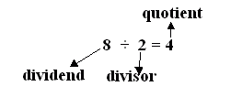
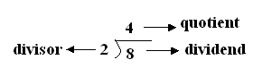
Both methods break down the really big dividends into smaller dividends (as shown in my examples above, the number of small dividends is determined by the digits in the divisor). These smaller dividends divide by the divisor again and again until it cannot be divided anymore (the number left would be called the remainder).
How does this method compare with our modern methods of division?
To use this method without a calculator, and especially for huge numbers, your mental calculation must be really up to a certain standard. Personally, my mental calculation is not that strong. For the above examples, I had to use a calculator for assistance. But, if a calculator was allowed, there is no need for this method. The calculator would do the job.
I think this method is really useful and easy to learn too! It is quite a fast way of dividing big numbers.

