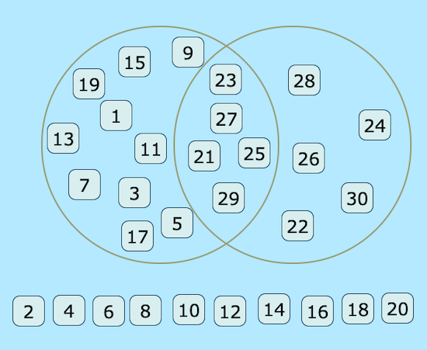
Even numbers over 20
Odd numbers

