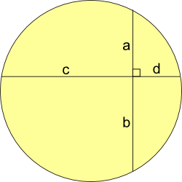
1:

Join a and d, and b and c, to make 2 triangles.
These triangles are similar because they have identical angles, as shown (bow-tie theorem).
So: a/c = d/b
ab = cd

2:

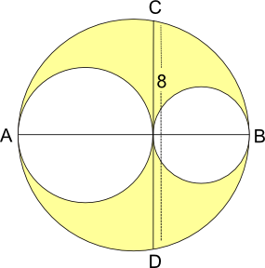
yellow area = area of big circle – area of other 2 circles

radius of smallest circle is r
radius of next circle is R
so radius of big circle is r+R

yellow area = $π$(r+R)² - $π$r² - $π$R²
= $π$(r² + R² + 2rR – r² - R²)
=$2π$Rr

Using the result from part 1: line CD is halved and the product of the 2 halves is the same as the product of the diameters of the 2 small circles.
2r x 2R = 16
rR = 4
yellow area = 8$π$
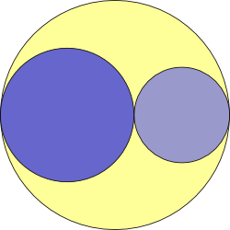
3:
yellow area = area of larger circle
∏R² = 2∏rR
R = 2r and biggest radius = r + R = 3r
ratio of radii = 1:2:3

