SOLUTION:
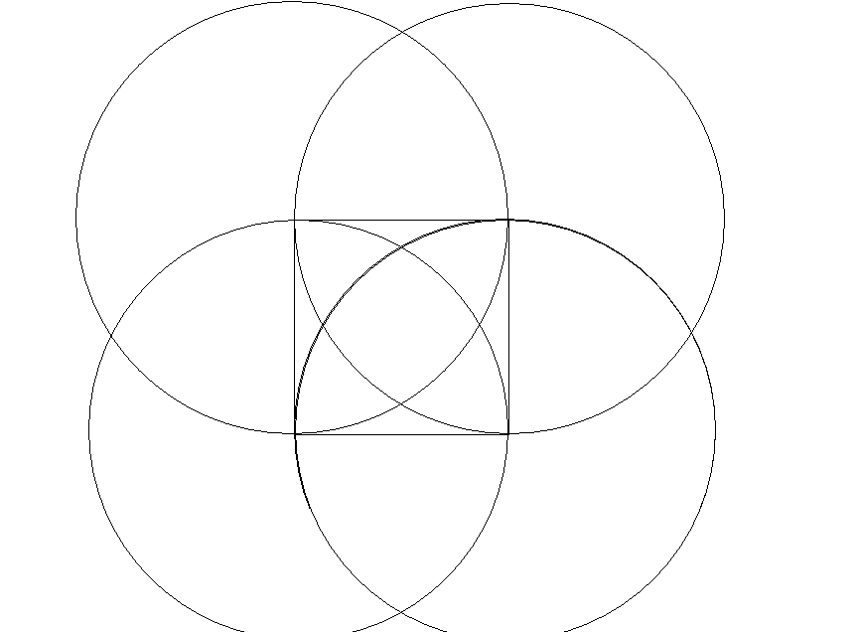
J
I
G
H
E
F
D
C
B
A

A, B, C, D are the centers of the four circles which form the square, circle A, B, C, D are all exact the same sized.
The first circle , A, was drew and using the same radiant, we can divide the circle into equally 6 bits. And B is one of those 6 points, from that point with still the same radiant, circle B was drew. Both intersecting points, I and H are both out of those 6 points. The same applied for the relation between circle C and D.
Since all 4 circles are exact the same
Due to such, we can say that curve DF=CF=BH=AH=BH=BE………
Also Curve AC=CA=BD=DB ……
Therefore curve AF=CG=BF=BG=DE=DH=AE=CH
Supposly we are to connect AH and AG with straight lines
Angle GAB = 360 / 6 = 60 degrees (we know that sector is 1/6 of a circle)
And Angle DAB = 360 /4 =90 degrees ( a quarter of a circle)
Therefore Angle DAH = Angle GAB =90-60=30 degrees (due to DH=BG)
So Angle HAG = 90-30-30 = 30 degrees = Angle DAH =Angle GAB
Hence Curve DH=BG=GH=DE=EF=FB=…….
Supposely we were to connect EFGH into a square (the biggest square possible)
AG = 1 (circle has the same radiant)
Cord GH = sin (30/2) * 1 * 2= 0.5176
Area of square = 0.518^2= 0.2679

Area of sector AFG = 1/12 * π * 1^2 =0.2618
Area of triangle AFG = ½ * 0.5176 * √ (1^2 – (0.5176/2)^2) = 0.2500
Area of a quarter of shaded area that cut by the cord = 0.2618 – 0.2500 = 0.0118
Area of shade = 0.0118*4 + 0.2679 = 0.3151

