Firstly, for finding the largest square that can be completely contained within the central region, let it be Q, I modified the sketch:
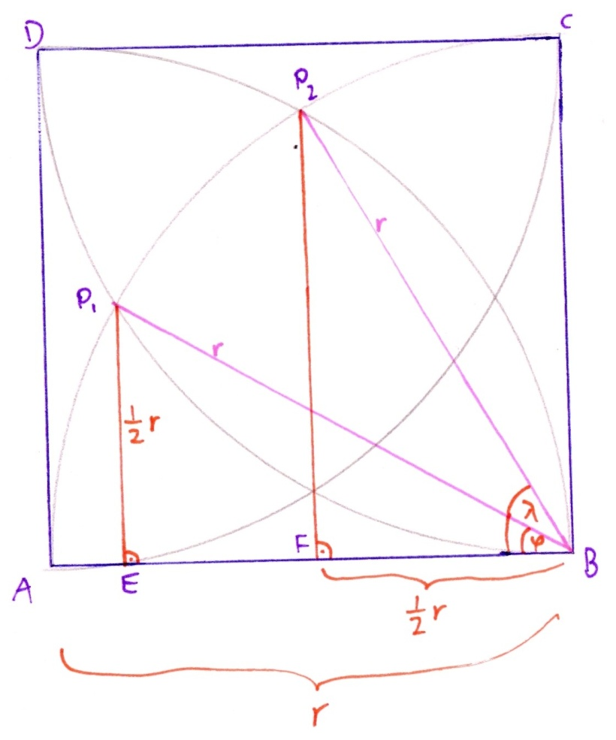

$$cosλ= \frac{FB}{r}=\frac{0,5 r}{r}=0,5$$
- $λ=arccos⁡(0.5)=60°$

$$sinφ= \frac{P_{1}E}{r}=\frac{0,5 r}{r}=0,5$$
- $φ=arcsin⁡(0.5)=30°$

According to the law of cosines (with r=1):
Q= ${(P_{1}P_{2})}^{2}= r^{2}+r^{2}-2r^{2}\cos\left(λ-φ\right)=2-2\cos\left(30°\right)=2-\sqrt{3}$

Then, the exact area created by the circles´ intersections inside the square at four points, let it be C, is $1-\sqrt{3}+\frac{π}{3}$ :

Area of the triangle $P_{1}P_{2}B=0,5 rrsin\left(λ-φ\right)=0,5\sin\left(30°\right)=0,25$
Hence,
$$C=Q+4 \left(\frac{\left(λ-φ\right)πr^{2}}{360°}-0,25\right)=2-\sqrt{3}+4\left(\frac{π}{12}-0,25\right)=2-\sqrt{3}+\frac{4π}{12}-1=1-\sqrt{3}+\frac{π}{3}$$

The exact area of central shaded region is $1-\sqrt{3}+\frac{π}{3}$.

