The cuboid challenge
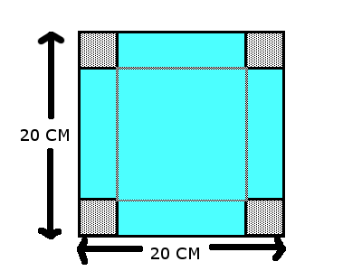
The cuboid challenge is when you have a square piece of paper 20cm by 20cm you can make a box without a lid by cutting out a square from each corner and folding up the flaps

And our challenge was to find the cut that gave the biggest volume and to solve a few questions:
- Will you get the same volume irrespective of the size of the squares that are cut out?
2. What is the maximum possible volume and what size cut produces it?
3. Try different sized square sheets of paper.
Can you find a relationship between the size of paper and the size of cut that produces the maximum volume?
So one by one we tried to answer all of these questions
1. Will you get the same volume irrespective of the size of the squares that are cut out?
To answer this question we started by having the cut out squares 1cm by 1cm and going up in single integers and our results were:
- 1cm x 18cm x 18cm= 324cm3
- 2cm x 16cm x 16cm= 512cm3
- 3cm x 14cm x14cm=588cm3
- 4cm x12cm x12cm=576 cm3
- 5cm x10cm x10cm=500cm3
- 6cm x8cm x8cm=384cm3

This answers the question with a simple no
Using this infromation we were able to create a graph showing our resluts :

2.The graph told us that the best cut size 3cm3 however we needed to be more presice so the table shows the cut size and the volume it gives including decimals
Cut size | volume
3.0 | 588
3.1 | 590.36
3.2 | 591.87
3.3 | 592.55
3.4 | 592.42
3.5 | 591.50
As with the eariler question we need a graph to make things clearer
So the best cut size is 3.3cm however if you went to more than two decimal places you will get to cut size 3.33 reocuring and we know that as 1/3 so the best cut size is 1/3
3. For question 3 we needed to try different sized paper so we tried 10cm by 10cm but the biggest cut size is not half of 1/3 but something different to work out what it was we needed an other table and another graph
Cut size | volume
1cm | 64cm3
2cm | 72cm3
3cm | 48cm3
4cm | 16cm3

So the largest cut size in whole interges is between 1cm and 2cm when the paper is 10cmX10cm
To find out what the largest cut size is in decimals we need an other table and graph
1.5 | 73.5
1.6 | 73.98
1.7 | 74.05
1.8 | 73.73
1.9 | 73.04
2.0 | 72
2.1 | 70.64
2.2 | 68.99

This graph shows that the best cut size is between 1.6 and 1.7. the best cut size is actually 1.66 reocuring which is also known as 1/6 and when you double it you get 1/3 so our idea about it being not half of one third was wrong
The relationship between the best cut size and the volume is that the cut size has to be a sixth of the lenght of side to get the largest volume

