Cuboid challenge

Length(l) = 20

x 20-2x x
All the cut out squares have length and width x. So the volume of the box is
$$volume of box={\left(20-2x\right)}^{2}\left(x\right)= 4x^{3}-80x^{2}+400x$$

By substituting in varying values of x we find that the volume is:
x-value | Volume of box ${(cm}^{2})$
1 | 324
2 | 512
3 | 588
4 | 576
5 | 500
6 | 384

The volume increases until approximately 3 and then decreases.
Graphically the equation appears to be:
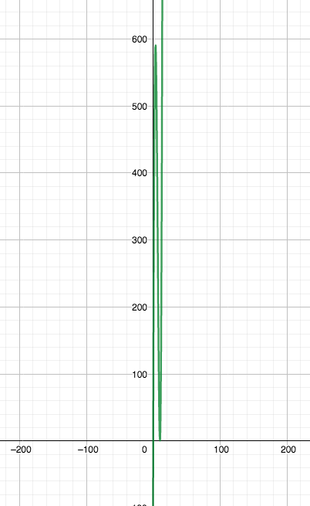
One extreme point of the cubic function is (3.3, 592.6) and the other is (10, 0). Logically, the value of x cannot exceed 10, as then the sum of 2x is larger than 20 cm. Thus the maximum y value is 592.6 when the x value is 3.3.

From this I can calculate that the formula for a box’s volume constructed from a square with any length (l) is
$volume=(l-2x)^{2}\left(x\right)=l^{2}x-4lx^{2}+4x^{3}$
Additionally the x value which gives the largest volume is $\frac{length of square}{6}$ .

The maximum value is the maximum stationary point of the graph which can be found using differentiation.
$$\frac{dy}{dx}4x^{3}-4lx^{2}+l^{2}x=12x^{2}-8lx+l^{2}$$
The maximum point’s derivative must equal 0, thus at the maximum $12x^{2}-8lx+l^{2}=0$.
By using the quadratic equation, the root values can be found.
$$\frac{8l±\sqrt{64l^{2}-48l^{2}}}{24}= \frac{8l±\sqrt{16l^{2}}}{24}=\frac{8l±4l}{24}$$
The maximum value cannot exceed half of the length of the square, thus the stationary point calculated is the smaller value. So the maximum point is at the x value
$$\frac{4l}{24}=\frac{l}{6}$$
This rule can be verified with the square of length 20.
$$\frac{20}{6}=3.33$$
Indeed 3.33 is the optimal value of x, to have the largest volume.

Then by this formula the largest possible volume for each box can be determined. If the optimal value of x is $\frac{l}{6}$ then the volume formula can be substituted by this and becomes
$$largest possible volume=({\frac{2l}{3})}^{2}\left(\frac{l}{6}\right)=\frac{{4l}^{3}}{54}=\frac{{2l}^{3}}{27}$$
Again, this can be verified with the 20 cm square.
$$\frac{{2*20}^{3}}{27}=592.6$$

