From a square sheet of paper 20cm by 20cm, we can make a box without a lid.
We do this by cutting a square from each corner and folding up the flaps.
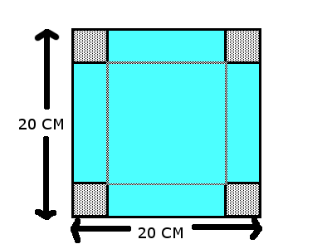
Will you get the same volume irrespective of the size of the squares that are cut out? Investigate what volumes are possible for different sizes of cut-out squares.
x

No. We won´t get the same volume irrespective of the size of the squares that are cut out. We imagine, if x has a small value, the height of this cuboid is small as well, but the base area will be large. If x has a large (but not infinitely large) value, cuboid´s height is large, too, whereas the base area will be small.

Let l be the edge length of the given square sheet, in our case, l=20 cm. After folded up, we obtain a figure shown below, whose volume V is $\left(x\right)=x{(l-2x)}^{2}=x{(20-2x)}^{2}$ .

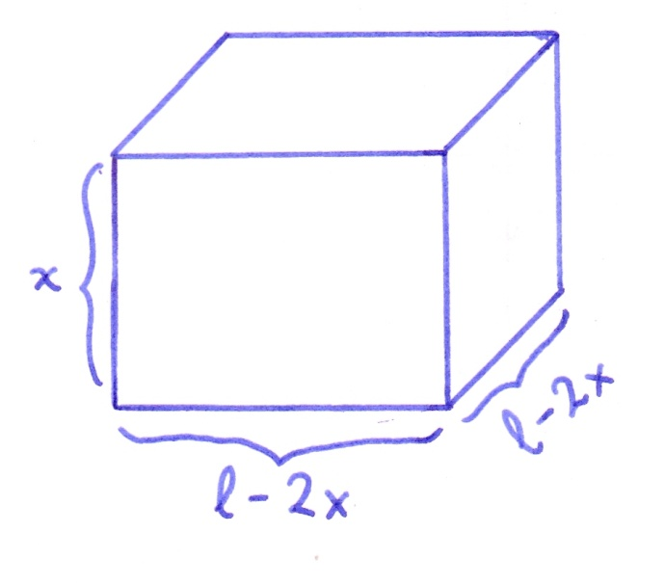
A graph can describe the changes of the volume V depending on the x-value. We label the volume V(x) on the vertical axis, x on the horizontal axis. Then the graph of the function
$V\left(x\right)={x(20-2x)}^{2}$ is the blue one drawn below which has the roots (function´s intersections with the horizontal axis) 0 and 10. Since a length is always nonnegative and in our case the value of x cannot equal 10 because of l=20 and if we cut x= 10 cm, then we will cut the given square sheet with an edge length l=20 cm in two halves, so we won´t obtain a such three-dimensional object like shown above. Thus, it is only possible that 0 < x < 10 when l=20 and the volume V varies depending on chosen x.
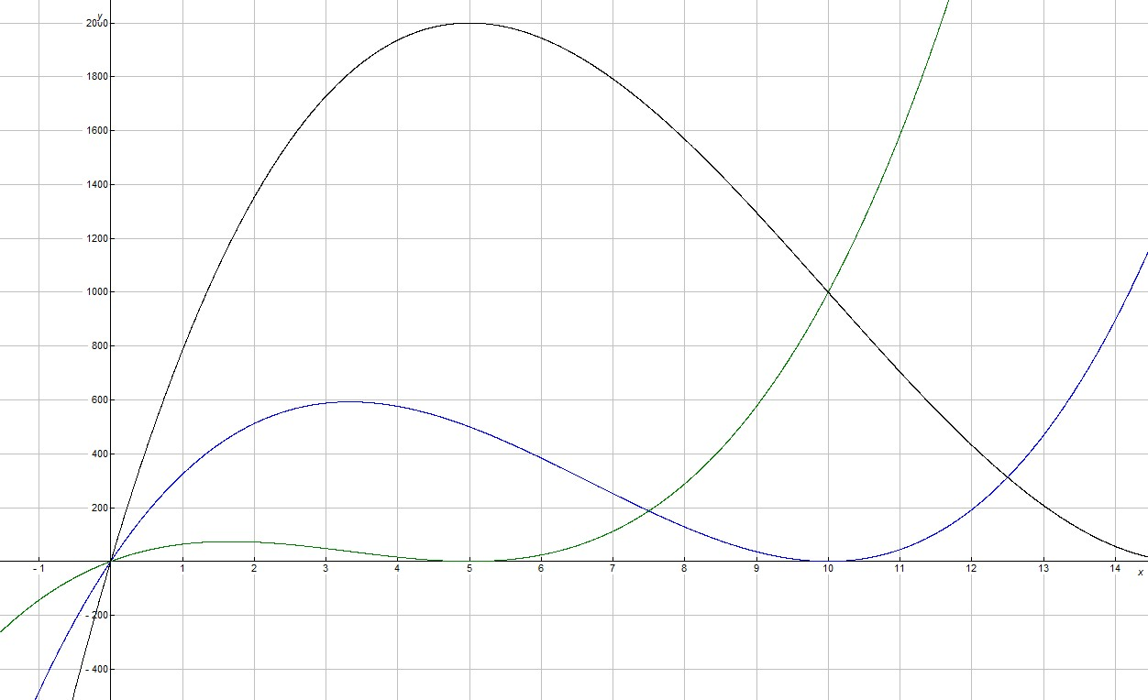

For example:
sizes of cut-out squares´ edge length  x (in cm) (0 < x < 10) | Volume V $V\left(x\right)={x(20-2x)}^{2}$ (in cm³)
1 | 324
2 | 512
3 | 588
8 | 128

What is the maximum possible volume and what size cut produces it?
The maximum possible volume is the maximum point of the graph of the function $V\left(x\right)={x(20-2x)}^{2}$ in the interval 0 < x < 10$x ∈$. For finding out the maximum point, we need the first derivative V´(x) of $V\left(x\right)={x(20-2x)}^{2}=4x^{3}-160x^{2}+400x$, which is $V´\left(x\right)=12x^{2}-160x+400$ and indicates the slope of V(x). At the maximum point, the slope is always 0, $´\left(x\right)=0, 12x^{2}-160x+400=0, x=\frac{10}{3}$ .
So, by cutting out $x=\frac{10}{3}$ cm, we get the maximum possible volume V_{max} =${\frac{10}{3} (20-2*\frac{10}{3})}^{2}≈592,59 { cm}^{3}$
Try different sized square sheets of paper. Can you find a relationship between the size of paper and the size of cut that produces the maximum volume?
Yes. The following table shows us the relationship between the size of paper and the size of cut that produces the maximum volume.
l= | $$V\left(x\right)={x(l-2x)}^{2}$$ | $$V´\left(x\right)$$ | $$V´\left(x\right)=0, x=$$
10 | $V\left(x\right)={x(10-2x)}^{2}$ * | $$V´\left(x\right)=12x^{2}-80x+100$$ | $$\frac{5}{3}$$
30 | $V\left(x\right)={x(30-2x)}^{2}$ ** | $$V´\left(x\right)=12x^{2}-240x+900$$ | $$\frac{15}{3}$$
L | $$V\left(x\right)={x(l-2x)}^{2}$$ | $$V´\left(x\right)=12x^{2}-8lx+l^{2}$$
graphs shown above in the coordinate system:
*the green one
** the black one

Generalization: $$V´\left(x\right)=12x^{2}-8lx+l^{2}$$
$$x=\frac{-b±\sqrt{b^{2}-4ac}}{2a} with a=12, b=-8l, c=l^{2}$$
$$x=\frac{8l±\sqrt{64l^{2}-4*12*l^{2}}}{24}=\frac{8l±\sqrt{64l^{2}-48l^{2}}}{24}=\frac{8l±4l}{24}=\frac{8l±4l}{24}=\frac{l}{2} or \frac{l}{6}$$
$\frac{l}{2}$ is not eligible because as we known, hereby we will cut the given square sheet with an edge length l in two halves and we won´t obtain a cuboid.

When the optimal size of cut-out squares´ edge length l=$\frac{l}{6}$ , then we obtain the maximum possible cuboid´s volume V_{max} =${\frac{l}{6} (l-2*\frac{l}{6} )}^{2}=\frac{l}{6}(\frac{2l}{3})^{2}=\frac{2}{27}l^{3}$
relationship:
ratio: edge length of paper (l): size of cut (x)that produces the maximum volume = l : $\frac{l}{6}$ =
6 : 1

