Probably a Code? – Mookie Chau

Firstly, at first glance, it seems that the frequency looks random which is not encrypted by monoalphabetic substation cipher method. In order to prove my hypothesis, Index of Coincident (IC) is calculated which is 0.044. Since the value is closer to the IC of Polyalphabetic substitution cipher method (0.038), it suggests that the plaintext is probably encrypted by Vigenere (one kind of periodic substation cipher). The IC value is calculated by a program online which you can find it from http://www.caconsultant.com/maths/ under frequency analysis.

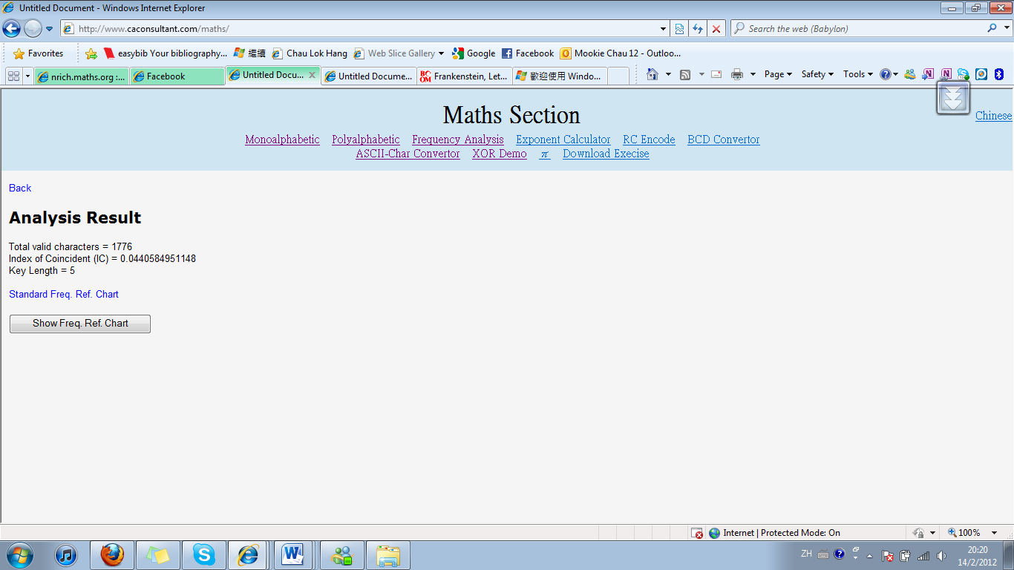
Before identifying the keyword used to encrypt the text, the length of the keyword should be found. It can be done by look for the sequences of letters that appear more than once in the ciphertext. The most likely is that the same sequence of letters in the plaintext has been enciphered using the same part of the key. Below is the list of sequences which appear more than once and their spacing between 2 of them is identified.

Repeated Sequence | Repeated spacing | Factor
npkju | 115 | 5 x 23
hgzwp | 35 | 5 x 7
cqiog | 795 | 5 x 159
uonct | 430 | 2 x 5 x 43
nkqqu | 550 | 2 x 5 x 5 x 11
jyqeo | 670 | 2 x 5 x 67
kzvkm | 490 | 2 x 5 x 7 x 7

By finding their common factor which is 5, this probably suggests that the key only contains 5 letters.

We proceed as follows. We know that one of the rows of the Vigenere square, defined by L_{1,} provided the cipher alphabet to encrypt the 1st, 6^{th,} 11th, 16th, … letters of the message. Hence we should be able to use old fashioned frequency analysis to work out the cipher alphabet in question. Below is the frequency analysis of different columns (i.e. different letters):

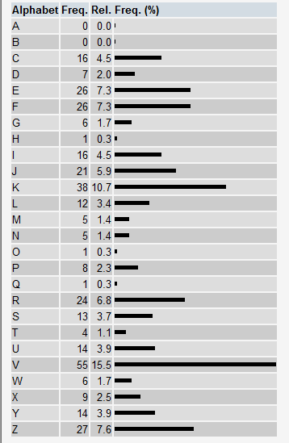
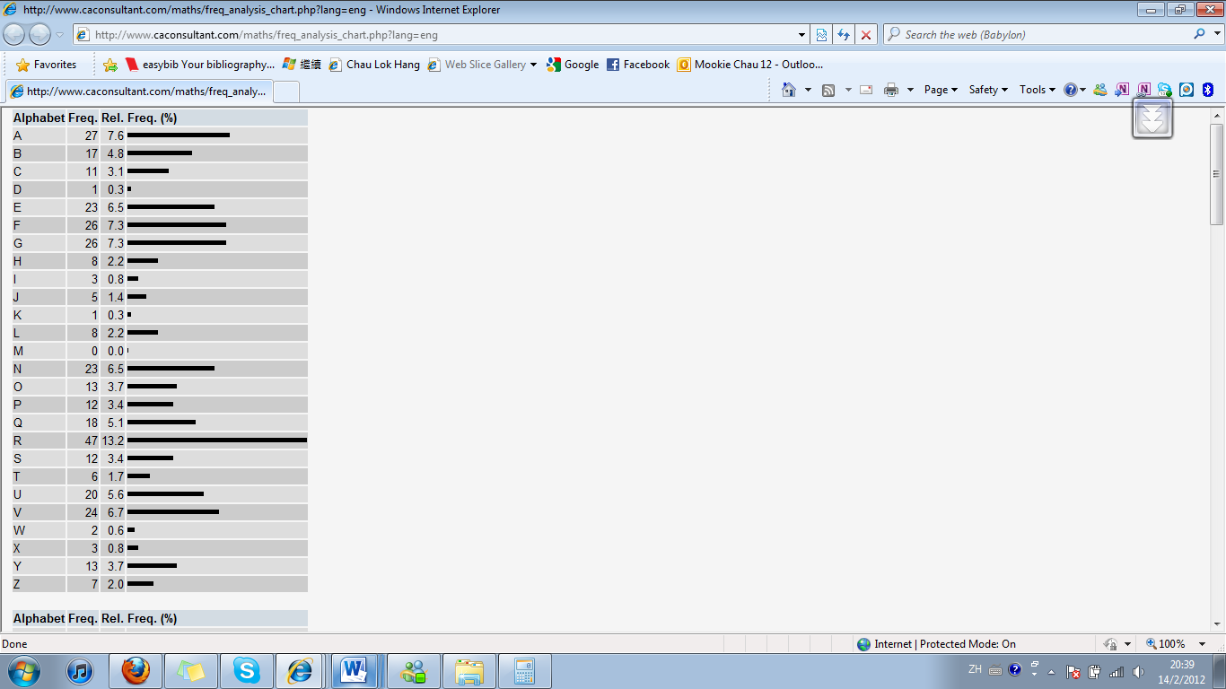

1st letter (L₁) 2nd letter (L₂)

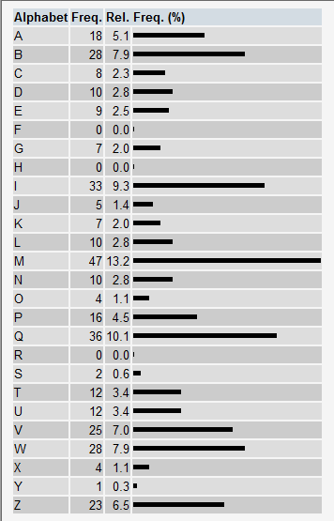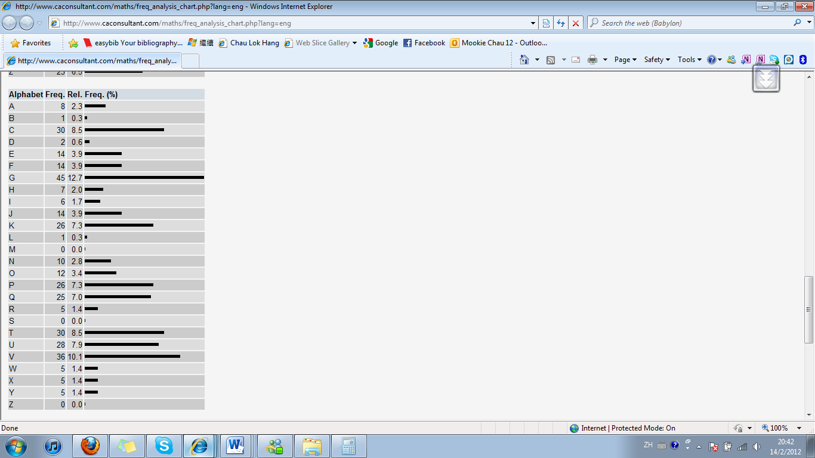
3rd letter (L₃) 4th letter (L₄)
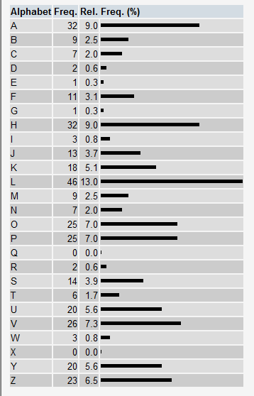
5th letter (L₅)

By using simple substitution cipher method to decode it (for example, the highest frequency of letters are “e”, “t” and “a”), the key of the Vigenere can be found which is NRICH in this case.

Finally, using the program of the wesbite http://www.caconsultant.com/maths/, the whole plaintext can be recreated. In this example the plaintext is extracted from Frankenstein, Letter 1 written by Mary Shelley.

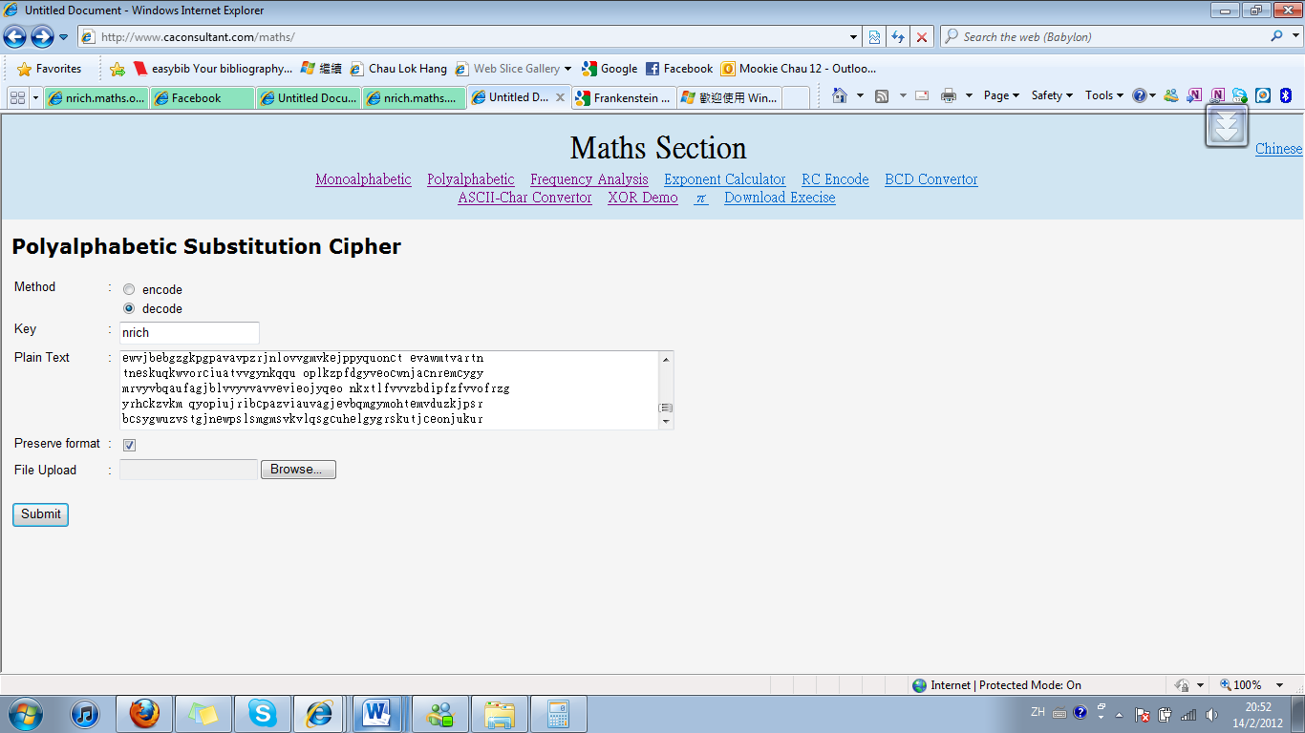

Plaintext:
I am already far north of London; and as I walk in the streets of Petersburgh, I feel a cold northern breeze play upon my cheeks, which braces my nerves, and fills me with delight. Do you understand this feeling? This breeze, which has travelled from the regions towards which I am advancing, gives me a foretaste of those icy climes. Inspirited by this wind of promise, my day dreams become more fervent and vivid. I try in vain to be persuaded that the pole is the seat of frost and desolation; it ever presents itself to my imagination as the region of beauty and delight. There, Margaret, the sun is for ever visible its broad disc just skirting the horizon, and diffusing a perpetual splendour. There -- for with your leave, my sister, I will put some trust in preceding navigators -- there snow and frost are banished; and, sailing over a calm sea, we may be wafted to a land surpassing in wonders and in beauty every region hitherto discovered on the habitable globe. Its productions and features may be without example, as the phenomena of the heavenly bodies undoubtedly are in those undiscovered solitudes. What may not be expected in a country of eternal light? I may there discover the wondrous power which attracts the needle; and may regulate a thousand celestial observations, that require only this voyage to render their seeming eccentricities consistent forever. I shall satiate my ardent curiosity with the sight of a part of the world never before visited, and may tread a land never before imprinted by the foot of man. These are my enticements, and they are sufficient to conquer all fear of danger or death, and to induce me to commence this laborious voyage with the joy a child feels when he embarks in a little boat, with his holiday mates, on an expedition of discovery up his native river. But, supposing all these conjectures to be false, you cannot contest the inestimable benefit which I shall confer on all mankind to the last generation, by discovering a passage near the pole to those countries, to reach which at present so many months are requisite; or by ascertaining the secret of the magnet, which, if at all possible, can only be effected by an undertaking such as mine.

Here is another ciphertext created by me using Polyalphabetic substitution cipher method. This one is using different keyword with different length (not NRICH):
CBIOI KKUTH PCUCQ ZXZVC IPSEE QEOII UZTXY ZTMSH WZPOA
LGZRP TYECR PPIIK HWGLR TTGEA MEIMP JLDGA HHKVJ WLLZV
TIAII IVQEY SGQAT KYJKV VAAFQ ZBVVV EQEOI ICTEO ESGBH
ZAZVK WPRXD MIDIV PBWLQ UWZXU KVPKX WLVTU TUXKJ MGLFP
EWCMY JKVVW SKGVI PECEZ NWXRP IAFWK UNDYI OCUES IYGZT
DIYCD TAAFR WHZMS NMRPT YGZPS TYCJT AWRPL LLGFW TSLRT
TGEAE DGAHH KVDGP SXVTV PAMEI JTAAV GVIOI DVWTU GIAXI
ALVOM HZEXG PTSPF YMLVY CFMCJ VPRBI OIWKZ HAPVV BTYET
EWGKM EIBDA LVHQG ZXTKX WLVRN XWHFV VADAL RVPQL GFOMH
HFLVE TDSLN LTUGI AXIAL VUMRV RUNMI AIICK RVVUK VVASK
JMHLG FPLRP TYGZP STYCJ TAWFV PPAIS GKDTI JHBDL RTTGE
AXYGB WPVUN MIAII YMGLX LTVIV XYGNX YWKEQ EOIIC TEOES
GBPUH KQMCJ VPRBI OIWQC GALCG BILVN GZTAY IPBDA LVUMR
VRUCT EOESG BIOMJ OMPUW KJIIA LVHQG ZXZKA TUGZR PTYIU
CAEIY KVPTZ ITQVS PMJGV RPTYG ZTKEJ CBWLJ ZPIAS IKVMG
VMJGV RPTYG ZTKET EWGKM EIBDA LVHQG ZXTKX WLVRN XWHFV
VICKF VEWBL WUVPT JSDRT TAITK XWLVK GFIYI RFAPM TRFBW
LGIWK XHPRF DPUXR IMDME CDMGA MJUGH AIDKA IOEKV PTZED
GTTAX VTQCA LVRTP PRKGF IKSVU VDARV EMHZE IKTNH TGGIG
HWKJM HHQVN MIAII KVIOI TKXWL VKGFI ZSKJM GLTVC BTKMZ
PPTSP FKATU GZRPT YIUFQ UMIIG VISCZ PMPJL TCATZ MDKTP
YPPVP TYIGG IILHR KVIOI TKXWL VKGFI YIGTM HLRKU ISPJW
GZTUX GNIXU XVZBA LXKGZ XUIRE PRHWV HQGZX YCVSA LVPQP
SXYQC VOLVJ ISOMK WXDUX YGUDZ XJKOC PJZEI CAFIG IZALI
QCVOM EGVRY CGVQD UJFTW KLVRV PDBWR PLNLE IUIAI IIVQU
HMCGL IVHVX MAVTY KARVR TGXIP RKQIU BPCAN DYQVF ANZXV
OWULR TTGEA MFPBW HXKCA ZMICN BDHHZ XMGZI XTWJW SWKVI
LPCGK IBECU EWVFL KTIVR YKAXU MKKIA PHVCN XYWKE IBLNF
JICUI JVZXA LVOQJ ZEXGZ BHRRD JDAFF TVXUX YGVVP SMCVC
PTFTB PHRZV IAPEE UKXLR KKAII SIPQC HRUHQ CHPCA JAHMJ
GLTCM XGVTY IRHZT UGYFQ ESSDC BQVVE KVKPK VPMGL FVEIB
LETSC PPRKG LLPXY VPTDV ZVQCN WFHIA IIIVQ IYMKJ MBPYJ
CVSWS IVILO IECBI OIRIM DMXNG VIFWZ ZPTDE JUMCA XFTWB
LSECB LVCVC ZSPTC QUPAM TOQHZ MFPBD ZXRTB LPXYJ QHPRK
GZTZX ZPKGF TKQOG HTYAE PZTLT MAFTI CKIPG RNICK ARUTX
UOVFB DOMJF QESSD CBXJA FTSIO IECBI OIRIM DMXYK ZIFRZ
PMKPK VPMGL HVEQS LHKJI IOIYC LPJGL OCAHX VFMCV YXJUD
UIPHW GOMDV WQLES NMIVE SCVSV RYKAR HVVGZ PUHTQ VRLRK
TIILS ECTXM IFHAI BHPKB LHWFP TNALV PBWHX YGMMH QZPMS
PRUGB PPPKJ MXKIR UWUHP SGZIP XIKBW LQZWA PUHGQ ZIHAV
CDXUK KJMBP RKQIR VLVTM CAEEF XDDII HCAUI NEQEO II

