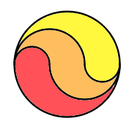
π×3²= 28.274
π×2²= 18.566
28.274 – 12.566 = 15.748
+ π(3.142) = 18.85
[πr²-π(⅔r)²+π(⅓r)] ÷ 2
[πr²-π(⅓r)²]÷2

Was calculated by finding the diameter (2cm) of the semi circle, finding the area and then halving it to get the whole of the semi-circle.

Was calculated by finding the diameter (4cm) of the orange area in which the area was ignored and found the whole area.

Was calculated by using the diameter of the whole circle (6cm) in which the semi-circle area was found whilst ignoring both and

To calculate the red proportion, we added and the proportions using the mathematical method above and found that all portions were equal.

