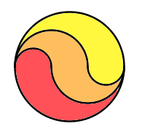
b
r=radius

a

$$\frac{πr^{2}-π{\left(\frac{2}{3}\right)}^{2}+{\left(\frac{1}{3}r\right)}^{2}}{2}$$
*Half of the circle subtract a gives the tail end of the red area. Then add b which is equivalent to the rest of the red shaded area on the other half of the circle

$$= \frac{π}{2}(\frac{9}{9}r^{2}-\frac{4}{9}r^{2}+\frac{1}{9}r^{2})$$
*Expand the brackets

$$\frac{π}{2}×\frac{6}{9}r^{2}=\frac{π}{2}×\frac{2}{3}r^{2}=\frac{2π}{6}r^{2}$$
*Simplify the fractions and symbols that appear multiple times until left with the simplified fraction

$$=\frac{πr^{2}}{3}=\frac{1}{3}=\frac{circle}{3}$$
*The whole area of the circle divided by 3 = 1/3 of its area
Therefore the red shaded area is equal to 1/3 of the circle’s area

