Pythagoras proof
What are you exactly trying to prove? – We are trying to prove how the Pythagoras theorem works and why it works. For example, we are proving: Why is the formula a²+b²=c²? How does this theorem work?
Method 1 – This method proves the theory by the following diagram:
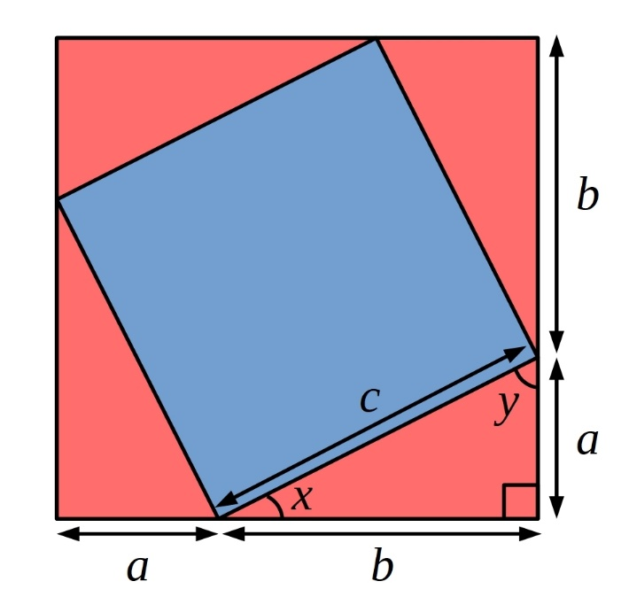
This proof is shown by making a square that has c length on each side, putting 4 identical triangles around the square, forming bigger square. We then can know that the four triangles’ area adds together to form the square in the middle, which is c². Therefore, the area of the enclosed square = the area of large square – area of the four triangles. The area of the large square is: (a+b)²=a²+2ab+b², and the area of the four triangles are: 4×1/2×ab=2ab. Then we can know that the area of the enclosed square is: a²+2ab+b²-2ab=a²+b². The area of the enclosed square is also given by c², therefore a²+b²=c².
Method 2 – Another method of proof is the following diagram:
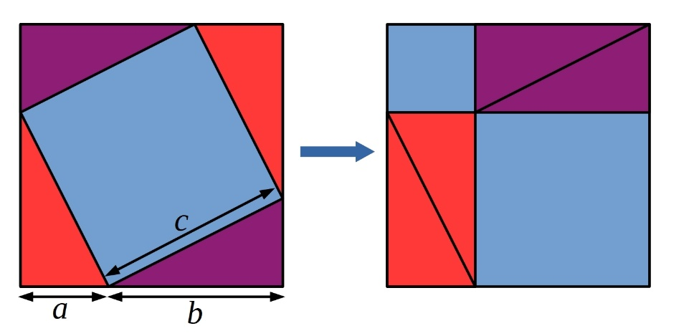
First, the area of the first square is given by (a+b)² or 4(1/2ab) + a² + b².
The area of the second square is given by (a+b)^2 or 4(1/2ab) + c².
Since the squares have equal areas we can set them equal to another and subtract equals. The case (a+b)²=(a+b)² is not interesting. So, the other case is: 4(1/2ab) + a² + b² = 4(1/2×ab) + c²
Subtracting equals from both sides we have a²+b²=c², which proofs the Pythagoras theory.
Method 3 – This method is shown by this diagram:
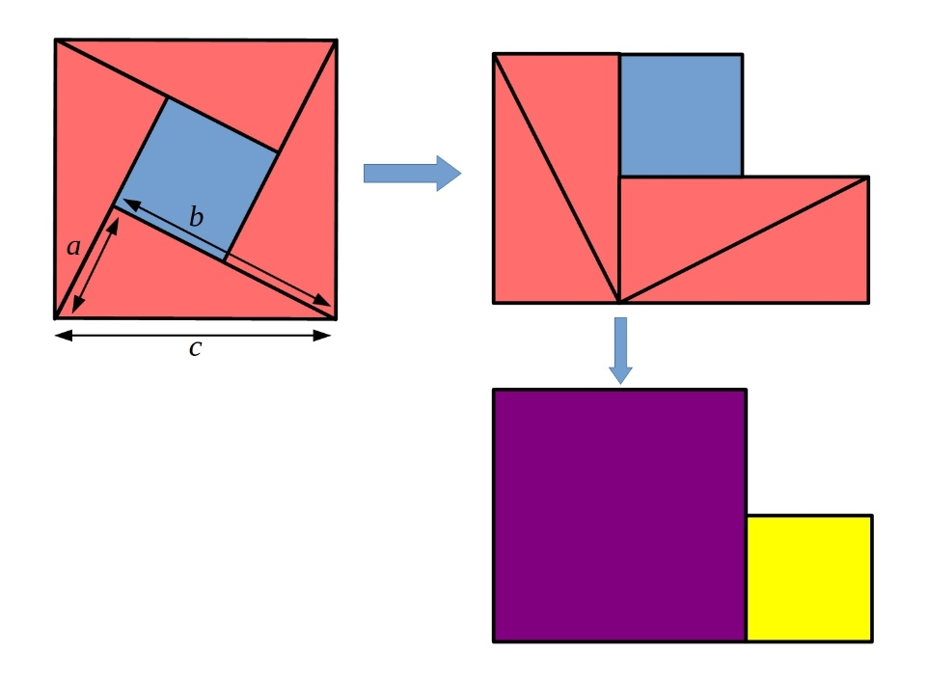
The first square has an area of c², and we can look the second shape as two squares – One small square (on the right) and one big square (on the left), shown on the last shape. Then, this shows a²+b², and we can see that the two area are equal, so a²+b²=c².
Which proof is the most “convincing”? – In my opinion, I think that second one is the most “convincing” because it uses a lot of math equations to show the proof.
Which proof is easier to understand? – I think that the last one is the most interesting and easy to understand because it basically uses shapes to illustrate The Pythagoras theorem.

