Solution to the ‘Classical Means’ Problem

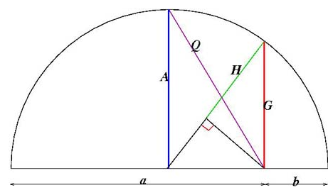
1) Prove that H = G²/A

E
C
D

My method for proving this will revolve around the notion of similar triangles and Pythagoras’ theorem:
C
E
C
H
90-x
90-x
x
x
D
G
The red and green triangles shown above are similar triangles as they have the same corresponding angles; therefore, the ratio of their corresponding side lengths will be the same. I have named the missing sides C, D and E.
From Pythagoras’ theorem C = √G²-H² and we also know that E = A-H as A is the radius of the circle.
Due to similarity, H/C = C/E
→ H/ (√G²-H² ) = (√G²-H²)/ (A-H)
→ HA -H² = G² – H²
→ HA = G²
∴ H = G²/A

2i) Prove A= ½ (a+b)
We know A is the radius of the circle and the diameter= a+b
Since radius = ½ diameter, A = ½ (a+b)

ii) Prove G = √ab
From Pythagoras’ theorem G² = (E+H)² – D²
We already know that E+H=A as it is the radius of the circle and A= ½ (a+b)
∴ E+H = ½ (a+b)
From the semicircle diagram, we know D = A – b but as A = ½ (a+b) , D = ½ a + ½ b -b = ½ a – ½ b
∴ G² = ( ½ a + ½ b)² – ( ½ a – ½ b)²
= ( ¼ a² + ½ ab + ¼ b²) – ( ¼ a² – ½ ab + ¼ b²)
= ½ ab + ½ ab = ab
∴ G = √ab

iii) Prove H = 2/ ( 1/a + 1/b)
We have already proved H = G²/A As G= √ab and A = ½ (a+b) H = (√ab)²/ (½ (a+b) )
= ab/ (½ (a+b) )
= 2ab/ (a+b)
= 2/ ((a+b)/(ab))
= 2/ ((a/ab) + (b/ab))
= 2/ (1/a + 1/b)

From the semicircle diagram it is clear that A>G as A² = G²+D² (see part ii) and therefore A is the hypotenuse of the green and red triangle combined. G is the hypotenuse of the green triangle so G>H
∴ A>G>H
3) Prove Q = √((a²+b²)/2)
From the semicircle diagram, it is clear that Q² = A² + D² We already know that A = ½ a + ½ b and D = ½ a – ½ b → Q² = ( ½ a + ½ b) + ( ½ a - ½ b)
= ( ¼ a² + ½ ab + ¼ b²) + ( ¼ a² – ½ ab + ¼ b²)
= ½ a² + ½ b²
= (a² + b²)/2
∴ Q = √((a²+b²)/2)

