Guruvignesh Balaji Year 10,
Hymers College
Classical Means
- H = 2/(1/a +1/b)
H = 2/(b/ab + a/ab) [Another way of expressing ‘H’]
H = 2*ab/(b + a) [To divide you can multiply by the reciprocal]
H = 2ab/(a+b) [The answer to the multiplication]
H (a + b) = 2ab [multiply both sides by ‘(a + b)’]
H*1/2 (a + b) = ab [Divide both sides by 2 or multiply by 1/2]
HA = G^2 [Replace the equations with their corresponding letters]
H = G^2/A [Divide by H]

ii.) Because the diagram is a semicircle and A is a straight line from the edge to the circumference, A is the radius of the circle and semicircle.
Since,
d=a + b [Diameter]
2r=d [Radius and diameter relationship]
r =1/2*d [Rearranged]
Then,
A=1/2(a+b) [Equation for the radius]
Therefore 2A=d
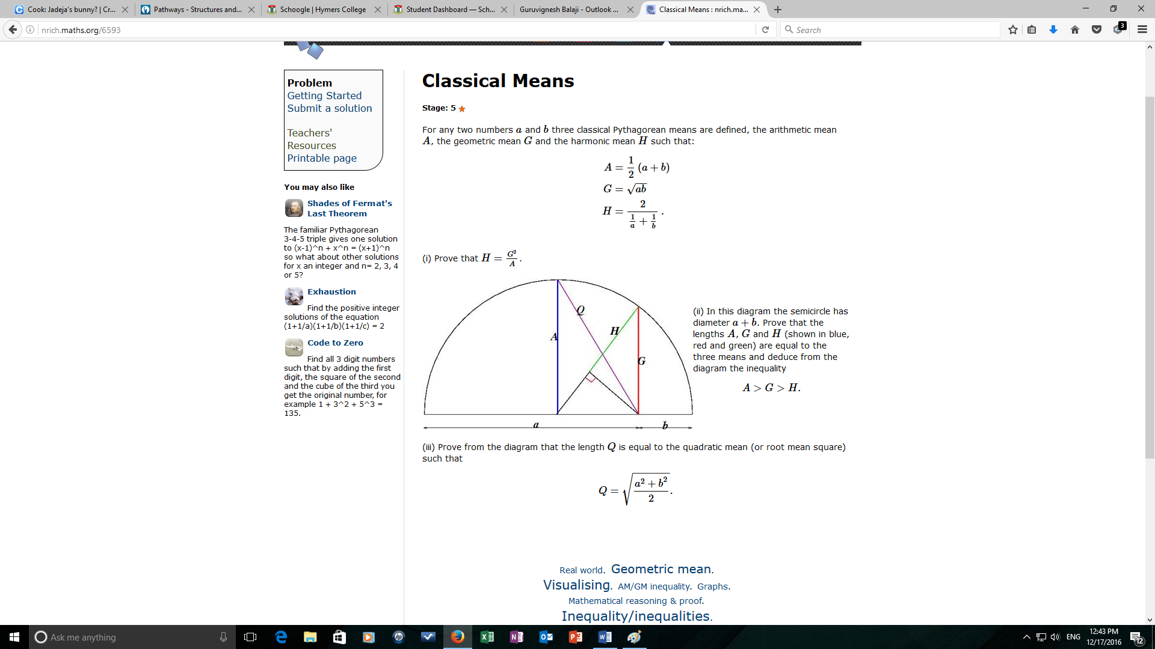
This is A (radius) minus ‘b’. Let this equal ‘x’. so, x= A-b
x= (a+b)/2 -b [substitute A= (a+b)/2]
x= (a+b)/2 - 2b/2 [Multiply so they have the same denominators]
x=(a-b)/2 [Subtract]

This line represents the radius, which is equal to A. Therefore, H plus a line is equal to ‘A’. A is the hypotenuse of that triangle (which has the right angle on the bottom left). So will be larger than G. However G is the hypotenuse of a triangle within the previous triangle so will be larger than H. Therefore:
A>G>H
Using the information, we can prove that ‘G’ is equal to the mean, √ab:
A^2- [(a-b)/2]^2= G [Pythagoras Theorem]
G^2= [(a^2+2ab+b^2)/4 – (a^2-2ab+b^2)/4 [Substitute A=1/2(a + b)]
G^2= 4ab/4 = ab [Subtract and Simplify]
G= √ab

We know that ‘H’ is the harmonic mean, which is the reciprocal of the arithmetic mean of the recriprocals.
A = ½(a + b)
H = 1/A
H = 2/(1/a + 1/b)

iii.) Q^2 = A^2 + x^2 [Let x= (a - b)/2] [Pythagoras Theorem]
Q^2 = (a^2 + 2ab + b^2)/4 + (a^2 - 2ab + b^2)/4 [Expand the equation]
Q^2 = (2a^2 + 2b^2)/4 [Subtract]
Q^2 = (a^2 + b^2)/2 [Simplify]
Q = √[(a^2 + b^2)/2] [Square Root both sides]

