What can you say about the angles on opposite vertices of any cyclic quadrilateral?

Diagram A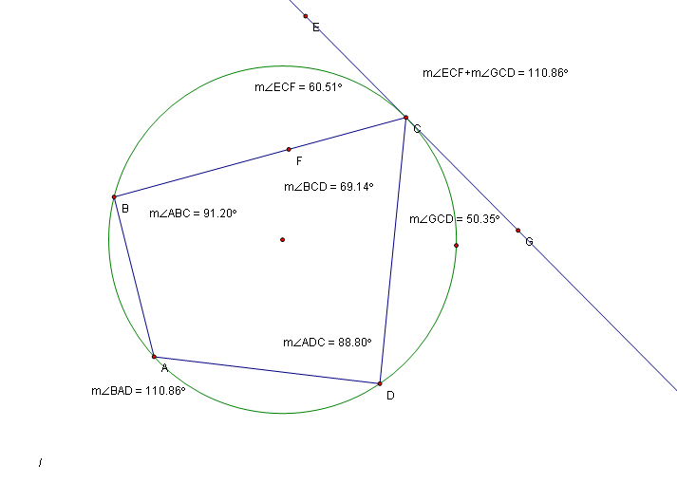

- The exterior tangent angles (angle ECF=60.51º and angle GCD=50.35º) will sum to the opposite inner angle (angle BAD=110.86º).
- Adding two opposite inner angles will equal 180º. (Example; Angle BAD- 110.86º + Angle BCD- 69.14º = 180º)

2nd question on next page.

Does your angle still work if the centre of the circle is not within the quadrilateral?

Diagram B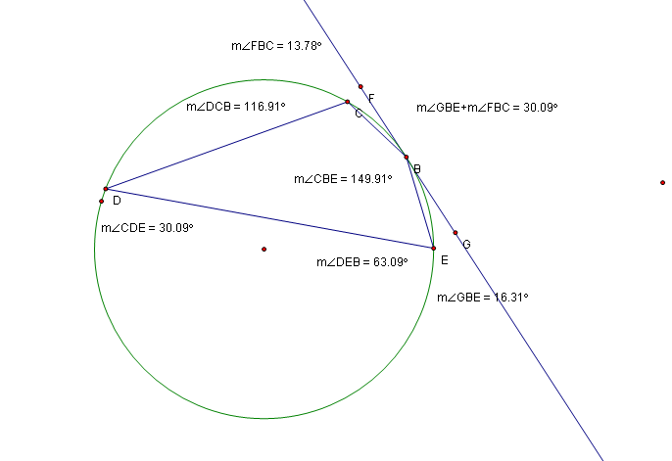
Yes, it will work even though the centre of the circle is not in the quadrilateral. Both points 1 and 2 as shown above on diagram A are the same and can be proven with this circle.

