question: if it is autumn now, what season will it be in 100 seasons?
In 1 year there are 4 seasons
Take 100 seasons and divide by 4
100÷ 4=25 years
If it is autumn now, in exactly 25 years it would still be autumn.
By: Katherine and Jack
Question: a railway line has 27 stations on a circular loop. If I fall asleep and travel through 312 stations where will I end up in relation to my starting place.
First you find out how many rounds there are in 312 stops 312÷27=11.55rounds
Then you find out how many stops there are in 11 rounds. 11×27=297stops
Next you find out how many stops she was from were she started 312-297=15
They woke up 15 stations away from their starting station.
By: Fred and Megan
Question: If a running track is 400 metres around, where will I be in relation to the start after running 6 miles (approximately 9656 metres)?
9656/400= 24.14
The runner can do 24 laps
24 x 400= 4600
that means that the runner has run 4600m
4656-4600=56
the runner has still got 56m to run
that is just over a quarter of the track
he would of done exactly 24 laps and 7/50
By: Fred and Amani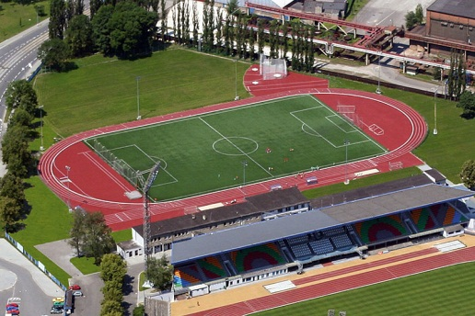
Question:If it is Monday what day will it be in a 100 days time ?
first I will divide a 1000 by seven 1000/7 which equals 142.8571429 and I round it up to 142 the I multiply 142 by 7 because now you are trying to find how many days there are which is 994 , that means that there are 994 days in 142 weeks . since it is a 1000 you just minus 4 from a thousand which is 994 (original answer) then you minus 4 days from Monday then you get then you get Sunday there fore the 1000th day is Sunday . this is by yasmine , using Luke's method.
Question: If it is midday now, will it be light or dark in 539 hours?
539/24= 22.46 days
0.46*24=11 hours left
let midday be 15:00,
15:00+11:00=27:00
27:00-24:00=03:00
03:00 is midnight, therefore it would be dark.
By: Jasmine, Fiona, Michael and Jet
Question : If I get on at the bottom of a fairground wheel and the wheel turns through 5000 degrees, whereabouts on the wheel will I be?
Method : First you have to try as get as close to 5000 as you can by multiplying 360 by 13 which is 4680. But you still have 320 and degrees left to spin through and as
you have done 13 rounds you have come back to where you have started so you turn 320 and 320 + 4680 is 5000 so you have spun through 5000 degrees.
Answer
1: Direction is south east
2: 320 degrees from where you originally started
3: On a clock face approximately 4:23
By: Markus and Gaeti
If it was November what month would it be in 1000 months
1 year has 12 months
1000 divide by 12 gives you 83.33........
This means 83.3 years 1/3 of a year which is MARCH
By:Fiona & Micheal
by ms wilsons math class gardenschool kuala lumpur
Bearings:
question: If I am facing North and I spin 945 degrees clockwise, which direction will I be facing in the end?
First we found out that going two rounds add up to 720 degrees (360 x 2). Then we minused 720 from 945 and the result was 225 degrees. We then had to find out in what direction was 225 degrees facing, so by halving 360 we get 180 and by halving 90 we get 45 so 180+45 = 225 degrees which ended up to be facing south west.
Answer: You will be facing South West after spinning 945 from North.

