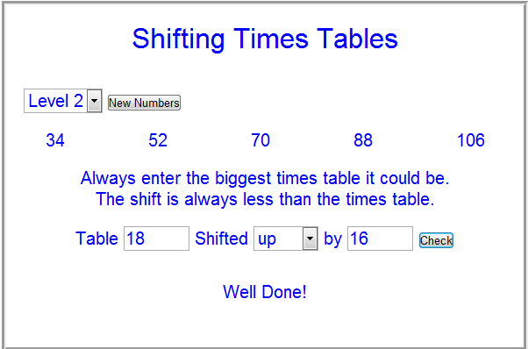
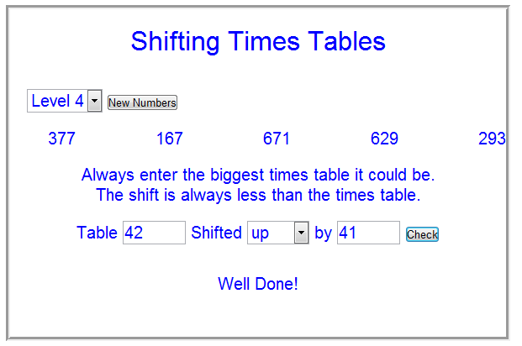
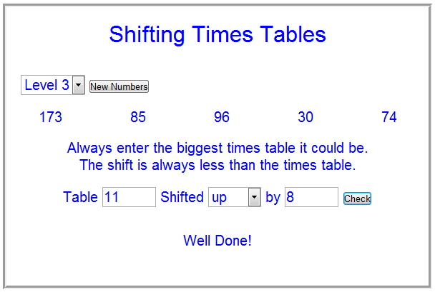
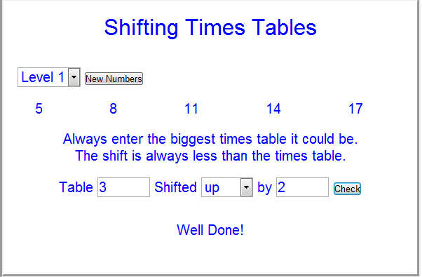

If the numbers are all odd, the table will be even and the shifted up number will be odd.
If the numbers are all even, both the table and shifted up numbers will be even.
If the numbers are a mixture of odd and even, the table will be odd and the shifted up number will be even.
14 24 34 44 54
If the unit’s digits are identical the table will be a multiple of ten and the shifted up number will be the same as the unit digit.
5, 10, 15, 20, 25 8, 13, 18, 23, 28
If there are only two different unit’s digits then the table must be a multiple of five and the shifted up number can be anything.
If the difference between the numbers is prime then the table will be a prime number and the shift number can be anything. If the difference between numbers is composite then the table will be composite.
The table will be the difference between the numbers closest to each other. The shift number will be the difference between the highest multiple of the table below the lowest number.

