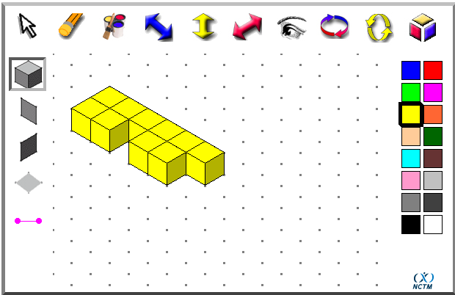
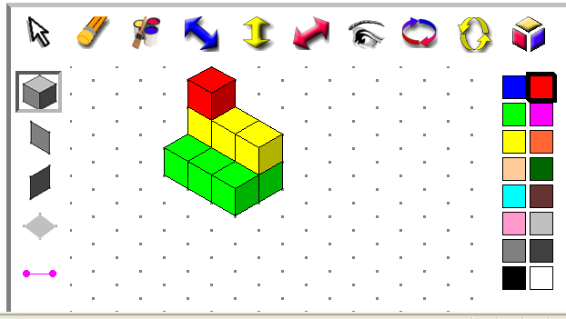
These are our solutions to the problem ‘So it’s 28’.
Amy and Kristy

