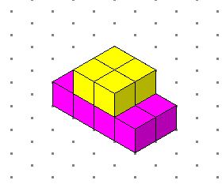
We have solved the problem “28 upwards and onwards”. This design shows 28 faces not including the bottom. We made it by using cubes and by doing guess and check.

It is stage 2!

