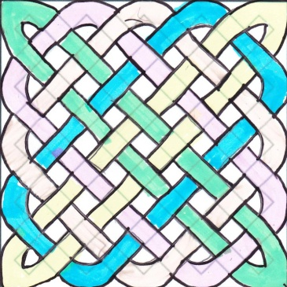
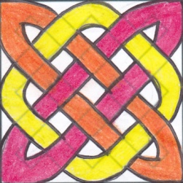
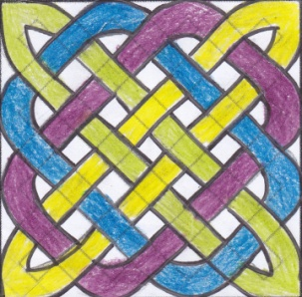
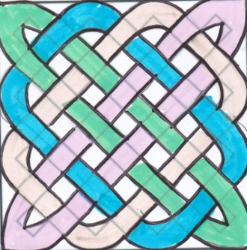

- Add the holes between the ribbons and minus 1 out of the total number. The answer determines the number of overlaps. $n-1=x$
- The number of ribbons on the top row indicates the amount of ribbons used in a pattern. (only the number of ribbons on one side)

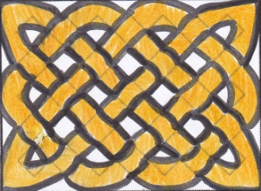
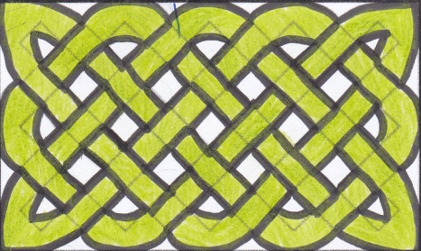

- Add up the holes between the ribbons and minus 1 out of the total number. The answer determines the number of overlapping ribbons. $n-1=x$
- Only 1, 2 or 4 ribbons can be used for a rectangle. If there are 31 overlaps, it cannot be divided by 2 & 4 because it is a prime number. This means the number of ribbons used is 1. If there are 72 overlapping ribbons, 72 can be divided by 2 & 4. The largest number which is 4 is equal to the number of ribbons used.

By: Kenn, Jong Woong, Jayme and Mariana from Garden International School

