Table Patterns Go Wild - by Rajeev Kumar
10 GRIDS AND DIFFERENT SIZED GRIDS
In a 10grid if only the last column is shaded then it is the ten times table and all numbers shaded will be multiples of 10. If the 5th and 10th columns are shaded then it is the 5 times table and all the shaded squares represent multiples of 5. If the grid is enlarged to 15by15 then if the 5th, 10th and 15th columns are shaded then again you get multiples of 5 and if it is a 20 grid then the 5th,10th,15th and 20th columns will be shaded and so on. You can call the pattern 5n as every 5th square is shaded but the grid must be also of a multiple of 5 i.e. 10,15,20,25 etc
In a 10 grid if the squares are shaded diagonally and in a positive slope(going up from left to right) and the diagonal line starts from the second last square of the top row then you will get multiples of 9 and it will be the 9 times table. The diagonal lines will be running parallel again starting from the last square in the 9th row of a 10 grid. So in any n grid , the last column will contain multiples of n, the positive diagonal line starting from n-1 will contain multiples of n-1 and the negative diagonal line(going down from right to left) staring from the first square of the second row will contain multiples of n+1.
Grid | Last column  Contains multiples of | Positive diagonal line starting from 2nd last square of 1st row contains multiples of | Negative diagonal line starting from 1st square of 2nd row contains multiples of | Positive diagonal line starting from last square of second last row contains multiples of
2 | 2
3 | 3 | 2 | 4 | 2
4 | 4 | 3 | 5 | 3
5 | 5 | 4 | 6 | 4
6 | 6 | 5 | 7 | 5
17 | 17 | 16 | 18 | 16
196 | 196 | 195 | 197 | 195

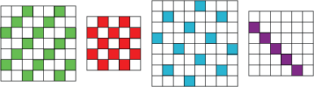
In any grid where every 4th square is shaded then it will contain multiples of 4 and so on .In the 7 grid as every 3rd square is shaded it has multiples of 3, in a 5 grid where every 2nd square is shaded you get multiples of 2 and in a 8 grid where every 5th square is shaded you get multiples for 5 and if you get a negative diagonal line in a 6 grid starting from the 1st square in 2nd row you get multiples of 7.
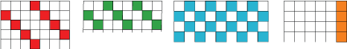
With regard to the top parts of the grids provided if it’s a 7 grid and every 4th square is shaded it contains multiples of 4. I have also noticed that the lines run parallel diagonally and the difference between the shaded squares is 3 in a 7 grid so every diagonal line will contain multiples of 4. I f the lines run diagonally parallel and the difference between shaded squares in a row is 2 then all the diagonal lines will have multiples of 3. Where every 2nd square is shaded then it contains multiples of 2 and as explained the last column in any grid will contain multiples of that grid.
Where the edges of the grid are not shown you can identify the tables used.
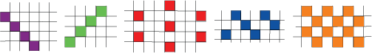
In the 1st grid the line is negative running diagonally and if more than 4 squares are shaded it must be a 6 grid or more and the tables could be 7 or more.
In the 2nd grid as the line is positive and running diagonally and if at least 4 squares are shaded the grid must be at least 5 by 5 or more.
With the 3rd pattern it is a 9grid and contains 6 times table, because the difference between the squares horizontally is 5 and vertically 1
Grid-must be multiples of 3 | Horizontal difference between shaded squares-(2g/3) -1 | Vertical difference between shaded squares | Times table  2g/3
3 | 1 | 1 | 2
6 | 3 | 1 | 4
9 | 5 | 1 | 6
12 | 7 | 1 | 8
15 | 9 | 1 | 10
18 | 11 | 1 | 12
57 | 37 | 1 | 38

With the 4th pattern it is an 8 grid and has multiples of 3. The grid could also be 11,14,17,20,23,98 as the difference is 2 horizontally between the shaded squares and any grid which is 3n+5 will make this pattern.
The last grid must be 8 or more and its size must be 2n+1>8≤ 2n and any such grid would make the last pattern.

