Table Patterns Go Wild soln by Sahunak
Which times tables made these patterns? Why?
Here are the tables and why those patterns are made by that table:
The first one is made by the table of 5. This is the table because the table of any factor of 10 will form straight lines. Something interesting is that, if the table is 5, then the number of straight lines formed is 10 / 2 = 5. If the table is 2, then 10 / 2 = 5 lines will be formed. This will introduce a property for different grids: A factor of the grid number (if there is a 10 grid then the grid number is 10) will form a straight line.
The second one is made by the table of 9. This is the table because in the table of 9, the next box is + 10 - 1 spaces away, or in other terms, one box down and one box to the left. If you continue this pattern, then we see a diagonal line forming.
The third one is made by the table of 4. This is because the number of spaces between two boxes is 3, which means the next coloured box is after 4 spaces.
These are the tables mentioned above:
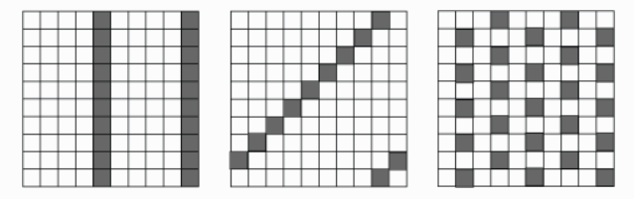

Which times tables made these patterns? Can you explain why they look like this?
The first one is made by the table of 3. This introduces another property: A factor of the number before the grid number will form a leftward diagonal line. 3 is a multiple of 7 - 1 = 6, so it forms such a pattern.
The second one is made by the table of 2. This introduces another property: If the grid number is odd, then a checked pattern is made by the table of 2. Here, the grid number is 5, so we get a checked pattern with the table of 2.
The third one is made by the table of 5. This is because the difference between two coloured boxes is 4, which means the next coloured box is after 5 boxes.
The fourth one is made by the table of 7. This introduces another property: The number before the grid number will form a rightward diagonal line. 7 is 6 + 1, so it forms such a pattern.

These are the tables mentioned above:

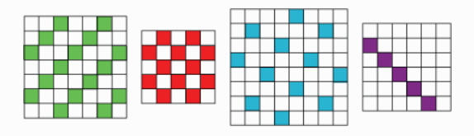
Have a go at working out what makes vertical and diagonal lines on the different grids.
Using some of the properties stated above, I was able to make straight lines and diagonal lines with any grid.
Can you make the checked pattern? What times table do you need to use on each grid?
Due to a property stated above (If the grid number is odd, then a checked pattern is made by the table of 2), I can make a checked pattern only if the grid number is odd.
Here are the top parts of some grids.
Can you identify which times table has been used to make each one?
The first one is made by the table of 4.
The second one is made by the table of 3.
The third one is made by the table of 2.
The fourth one is made by the table of 6.

These are the tables mentioned above:

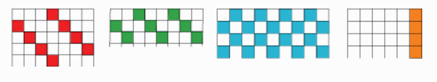

Here are some parts of various grids. This time we have not shown the edges of the grids. Can you identify which times tables on which grids could have been used to make these patterns?
The first pattern can be made by any grid between 6-12 grid and the table is one greater than the grid number.
The second pattern can be made by any grid between 5-12 grid, and the table is one less than the grid number.
The third pattern is made by the table of 6 in 9 grid.
The fourth pattern can be made by 8 grid and 11 grid and the table is always 3.
The fifth pattern can be made by 9 grid and 11 grid and the table is, in both cases, 2.

These are the tables mentioned above:

