Post box problem

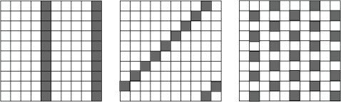
five times tables - I know because I counted how many blocks it takes to get to the next shaded one.
nine times tables- I know because I counted how many blocks it takes to get to the next shaded one.
four times tables- I know because I counted how many blocks it takes to get to the next shaded one.

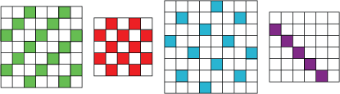
three times tables-I know this because if you count how many blocks it takes to get to a shaded one you know the answer.

two times tables-I know this because if you count how many blocks it takes to get to a shaded one you know the answer.

five times tables-you count the blocks again to get your answer.

seven times tables-you can count the blocks again.

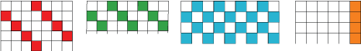

Four times tables-you can work this out by counting the blocks on the top of the square until you get to a shaded one. Another way you can do this is by making a 100 square and finding out the times table.

Three times tables-you can work this out the same way you did in the one before.



Two times tables-this question is tricky because it only shows you the a part of the number square which makes it harder.

