Table Patterns Go Wild Solution for nrich

Myself Shubhangee (Facilitator) had worked collaboratively on ‘Table Patterns Go Wild’ with a group of 10 students of 1st to 3rd grade, in online mode, in ‘Ganit Kreeda’, Vicharvatika, India. The names of the students are:
Abhyudh, Viyaan, Aditi, Mridula, Pushan, Shravani, Veyhant, Anika, Kiaan, Shreehari.
We worked for 3 sessions on this task in a very systematic way.
.
Have a look at the 10 grids below.
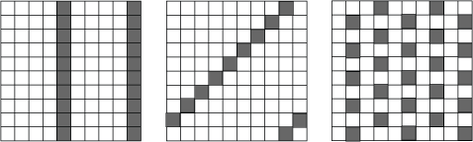
- Which times tables made these patterns? Why?
Ans: The first 10 grid’s pattern is made by the table of 5.
The second 10 grid’s pattern is made by the table of 9.
The third 10 grid’s pattern is made by the table of 4.
In the 1st 10 grid, 5 and 10 boxes are colored in the first row, 15 and 20 boxes are colored in the second row, 25 and 30 boxes are colored in the third row and so on.
In the 2nd 10 grid, first 8 boxes are empty, 9th box is colored in the first row, 18th box is colored in the second row, 27th boxes is colored in the third row, 36th box is colored in the fourth row, and with this I found out the table.
In the 3rd grid, 4th and 8th boxes are colored in the first row, 12th, 16th and 20th boxes are colored in the second row, 24th and 28th boxes are colored in the third row and with this I found the table.

- We are going to look at the patterns made on square grids of other sizes, from 4 grids (a 4 by 4 grid) to 9 grids.
These are patterns made on a 7 grid, a 5 grid , an 8 grid and a 6 grid respectively:
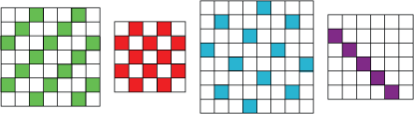

Which times tables made these patterns? Can you explain why they look like this?
Ans:
7 grid = 3 times table
5 grid = 2 times table
8 grid = 5 times table
6 grid = 7 times table

Below is Veyhant’s work:
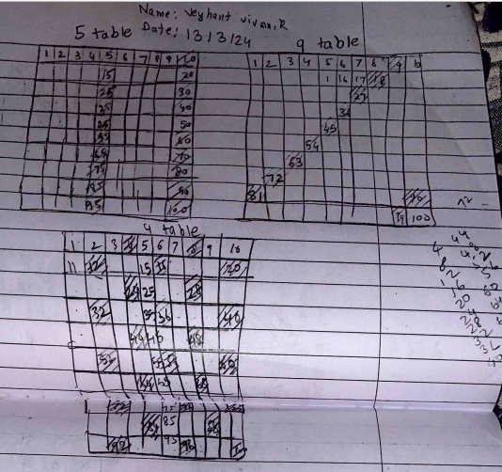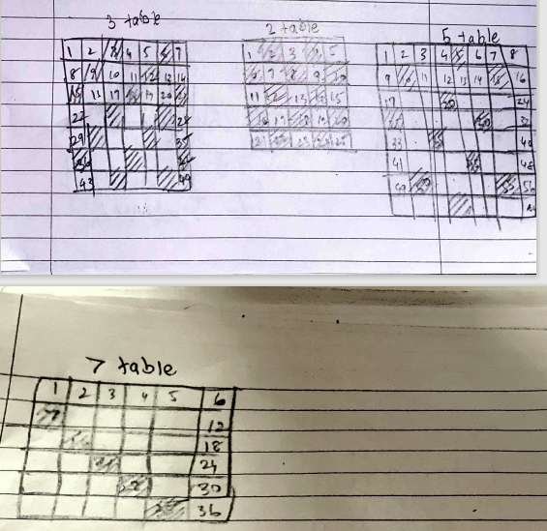

Q.1: Can you find a way to get a straight line for any grid size? What times table do you need to use on each grid?

Ans: Yes, we can always find a straight line.
This is how we can find a straight line:
Check all the numbers from the first row except for 1, that are factors of the grid number (if it is a 5 grid then the grid number is 5), then colour all the numbers in that number’s table.
Ex: Tables 2,3,4,6 and 12 will form a straight-line pattern on 12-Grid.

Q.2: Can you find a way to get a diagonal line for any grid size? What times table do you need to use on each grid?

Ans: Yes, we can always find a diagonal line.
There are two types of diagonal lines - upper left to lower right or upper right to lower left. Both can be formed with any grid.

This is how we can find a diagonal line from upper right to lower left:
i) Find the grid number.
ii) Colour the table of the number which is one smaller than the grid number. We find that this pattern makes a diagonal line.
Ex: Table 4 on 5-Grid, table 6 on 7-Grid , table 11 on 12-grid.

This is how we can find a diagonal line from upper left to lower right:
i) Find the grid number.
ii) Color the table of the number which is one greater than the grid number. We find that this pattern makes a diagonal line.
Ex: Table 6 on 5-Grid, table 7 on 6-Grid , table 13 on 12-grid.
Q.3: Can you find a way to get a checked pattern (Pattern on chess board) for any grid size? What times table do you need to use on each grid?

Ans: No, we cannot get a checked pattern for any grid size. I can do it only if the grid number is odd.
This is how we can get a checked pattern:
i) Check the grid number. Determine if the grid number is even or odd. If it is even then we cannot get a checked pattern. If it is odd, only then we can make a checked pattern.
ii) 2 is the only number which can make a checked grid with an odd grid number.
This happens because 2 is the only number who’s table has 1 number between two consecutive multiples, that is, gap of 1 number. Table of 2 can make a checked pattern with any odd grid number.

Here is Veyhant’s work:
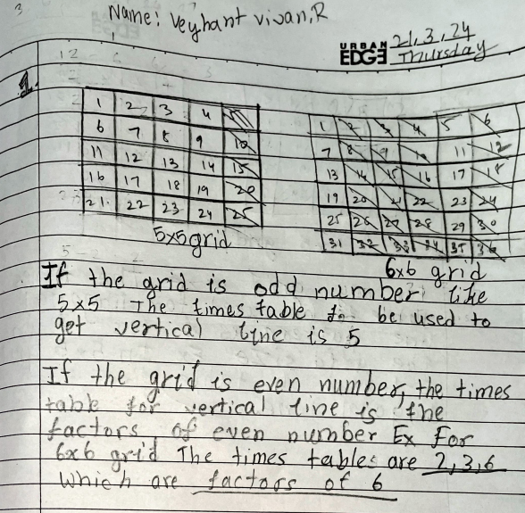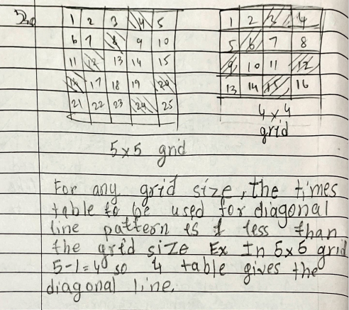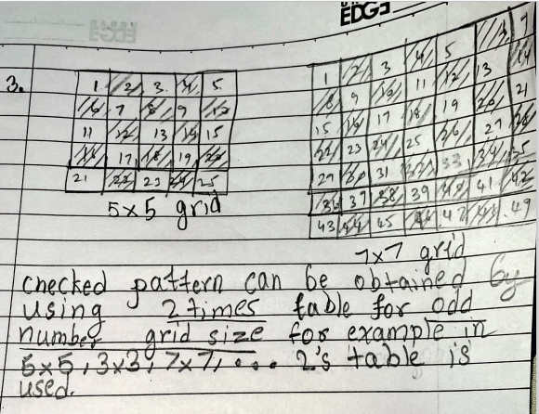
able P

All the kids worked on Sheet B and come up with the solutions as shown here.
All the kids worked on
!Sheet B
Here are some parts of various grids.
Can you identify what table, on what grid have been used to make these patterns? 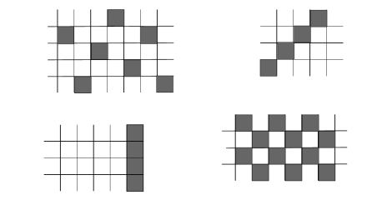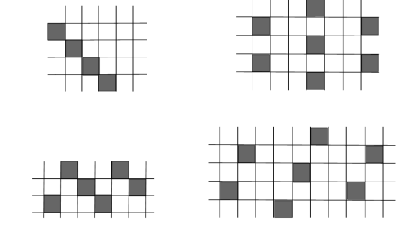The grids are all between 5 x 5 and 12 x 12.

- The first pattern is made by the table of 5 in 8 grid.
- The second pattern can be made by any grid between 5-12 grid, and the table is one less than the grid number.
- The third pattern can be made by any grid between 6-12 grid and the table has to be the same as the grid number.
- The fourth pattern can be made by 9 grid and 11 grid and the table is, in both cases, 2.
- The fifth pattern can be made by any grid between 6-12 grid and the table is one greater than the grid number.
- The sixth pattern is made by the table of 6 in 9 grid.
- The seventh pattern can be made by 8 grid, 10 grid and 11 grid and the table is always 3.
- The eighth pattern is made with the table of 11 and the table is 7.
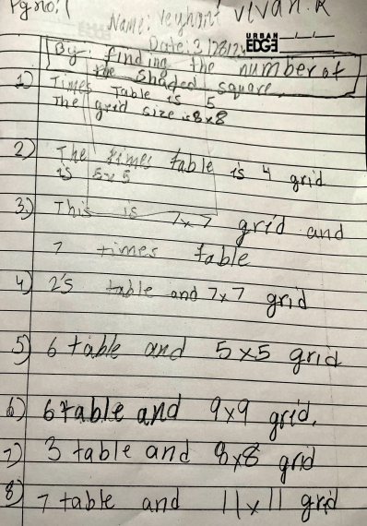

Click on the link to see Shravani’s explanation:
https://youtu.be/tgsqxrgDubY

