Counting Cogs Solution Nrich
Myself Shubhangee from Ganit Kreeda, India, worked on Counting Cogs. I would like to share my approach.
I experimented with different pairs of cogs. I marked a tooth on the first cog with a black dot. As the two cogs move around each other, I noted which gaps on second cog the marked tooth goes in to.
After few trials, I thought this whole system in a different way as: if I cut the cog and make a strip of both the cogs. Then I kept them next to each other and noted about the dot on one cog was matching with which gap.
I also tried to find out when they will come back to original position. Here are the observations, I labelled the cogs with 4 teeth as C4, cog with 5 teeth as C5…

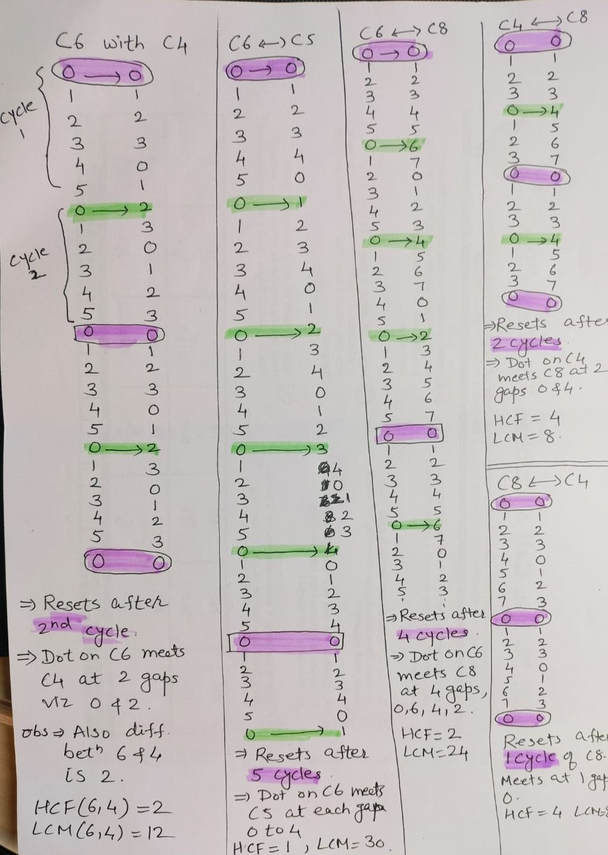

I tabulated the results as:
Teeth on Cog 1  (A) | Teeth on Cog 2  (B) | Dot on cog 1 meeting gaps on cog 2 | Difference between 2 gaps. | HCF (A,B) | Reset after how many cycles. | LCM(A,B) | LCM / teeth on C1
6 | 4 | 0,2,0,.. | 2 | 2 | 2 | 12 | 12/6 = 2
6 | 5 | 0,1,2,3,4,0,.. | 1 | 1 | 5 | 30 | 30/6 = 5
6 | 9 | 0,6,3,0,.. | 3 | 3 | 3 | 18 | 18/6 = 3
8 | 4 | 0,0,.. |  | 4 | 1 | 8 | 8/8 = 1
4 | 8 | 0,4,0,.. | 4 | 4 | 2 | 8 | 8/4 = 2
5 | 4 | 0,1,2,3,0,.. | 1 | 1 | 4 | 20 | 20/5 = 4
4 | 6 | 0,4,2,0,.. | 2 | 2 | 3 | 12 | 12/4=3
4 | 12 | 0,4,8,0,.. | 4 | 4 | 3 | 12 | 12/4=3
5 | 15 | 0,5,10,0,.. | 5 | 5 | 3 | 15 | 15/5=3

I found that
- # of iterations/rotations = LCM(A,B) / A(teeth on cog 1)
- Interval between 2 meeting points = HCF(A,B)

I connected it with modular arithmetic as after each cycle cogs are resetting back to 0 (original position, exactly like a clock).
I tried it with Cog 4 and Cog 6.

After first complete rotation/cycle of C4(A), A0 will meet C6(B) at 4 as 4 is equivalent to 4 in mod 6.
Then for the next cycle of C4, we will find what is 8 in mod 6? and that is 2. So, B2 is the next meeting point.
Again, I will try for next complete cycle of C4 and that means we need to find out what is 12 in mod 6?
As it is 0, we stop the process here as we reached back to original position.
Clearly, two cogs will meet again after the number of steps equal to its LCM. From number of steps we can calculate the number of rotations taken by each cog.

Q.1: Which pairs of cogs let the coloured tooth go into every 'gap' on the other cog?
The coloured tooth goes into every 'gap' on the other cog for the pairs of cogs whose number of teeth are co-prime or with HCF = 1.
Q.2: Which pairs do not let this happen? Why?
The pairs of cogs whose number of teeth are not co-prime or have common factor other than 1, do not let this happen.
Q.3: Can you explain how to determine which pairs will work, and why?
We can simply check if HCF = 1, then this will happen. In all other case, this will not happen.

