Counting Cogs Solution Nrich (Collaborative)
Myself Shubhangee (Facilitator) had worked collaboratively on ‘Counting Cogs’ with a group of 12 students of 3rd to 6th grade, in online mode, in ‘Ganit Kreeda’, Vicharvatika, India. The names of the students are:
Ahana, Sehar, Saanvi, Dhanvin, Aariz, Ananthjith, Vivaan, Sai, Pranathi, Paavani, Utkarsh, Dhruv.
Kids experimented with different pairs of cogs. We marked a tooth on the first cog with a black dot. As the two cogs move around each other, we noted which gaps on second cog the marked tooth goes in to. Kids called cog as wheel.
We also tried to find out when they will come back to original position.
How many rotations are completed by cog1 and cog 2? Here are the observations:
Wheel 1 (A) | Wheel 2 (B) | Original position of A & B | Gaps where dot on A meets B | # of rotations completed by A | # of rotations completed by B | Difference between the gaps | # of steps taken by each wheel | HCF(A, B) | LCM(A, B)
4 | 5 | A1-B1 | B5, B4, B3, B2, B1 | 5 | 4 | 1 | 20 | 1 | 20
5 | 6 | A1-B1 | B6,B5,B4,B3,B2,B1 | 6 | 5 | 1 | 30 | 1 | 30
4 | 6 | A1-B1 | B5, B3, B1 | 3 | 2 | 2 | 12 | 2 | 12
4 | 8 | A1-B1 | B5, B1 | 2 | 1 | 4 | 8 | 4 | 8
6 | 9 | A1-B1 | B7, B4, B1 | 3 | 2 | 3 | 18 | 3 | 18
5 | 10 | A1-B1 | B6, B1 | 2 | 3 | 5 | 10 | 5 | 10
5 | 15 | A1-B1 | B6, B11, B1 | 3 | 1 | 5 | 15 | 5 | 15
4 | 9 | A1-B1 | B5, B9, B4, B8, B3,B7,B2,B6,B1 | 9 | 4 | 4 | 36 | 1 | 36
4 | 12 | A1-B1 | B1, B5, B9 | 3 | 1 | 4 | 12 | 4 | 12

First, we tabulated first 4-5 columns and then slowly, we added other columns in the process as different kids raised different questions. Kids noticed that
- number of steps taken by each wheel = LCM(A,B)
- Difference between the gaps of matching wheel = HCF(A,B)
Initially, kids found the Gaps where dot on A meets B by using cut-outs of cogs. Slowly, they followed one common method as:
Ex: Wheel 6 and wheel 9
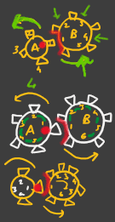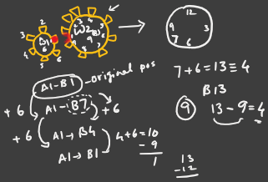
Original position of wheel(A) & wheel(B) is A1-B1.
As Wheel A completes its rotation, it will advance through 6 steps and B will also advance through 6 steps. So, after 6 steps A1 will face B(1+6) i.e. A1-B7.
Next will be 7+6=13 and as we don’t have 13 on the wheel, we can subtract 9 (the maximum number we have on the wheel) to get B4. Then 4+6=10 & 10-9=1. So, B1.
Now, kids were asked one question by Shubhangee…. can you relate it with something else that you use every day? After some thought they came up with the answer Clock. Then I asked them now its 7 o’clock and what time it will be after 6 hours? So, they said 1 o’clock and then we observed that how exactly same method is used in both the cases. 7 + 6 =13 and then subtract 12 from 13 which will give 1.
It was very thought provoking and insightful session.
Q.1: Which pairs of cogs let the coloured tooth go into every 'gap' on the other cog?
The coloured tooth goes into every 'gap' on the other cog for the pairs of cogs whose number of teeth are co-prime or with HCF = 1.
Q.2: Which pairs do not let this happen? Why?
The pairs of cogs whose number of teeth are not co-prime or have common factor other than 1, do not let this happen.
Q.3: Can you explain how to determine which pairs will work, and why?
We can simply check if HCF = 1, then this will happen. In all other case, this will not happen.

Attaching few students’ pics.
Ananthjith’s solution:
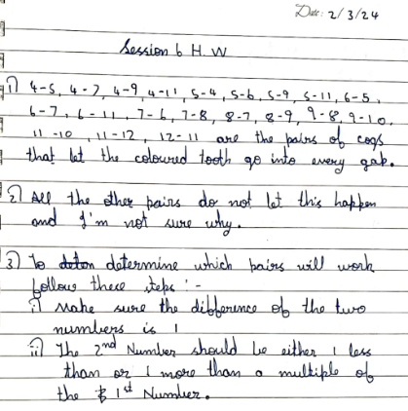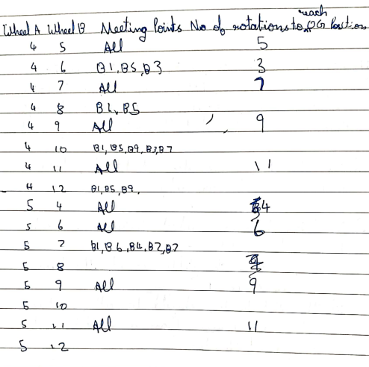
Sehar’s work:
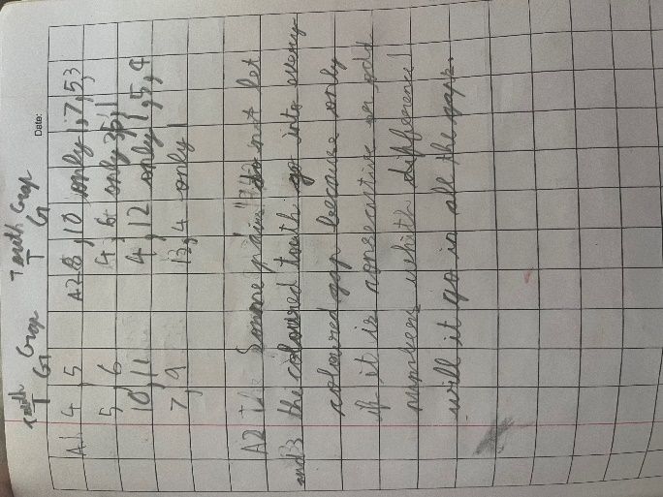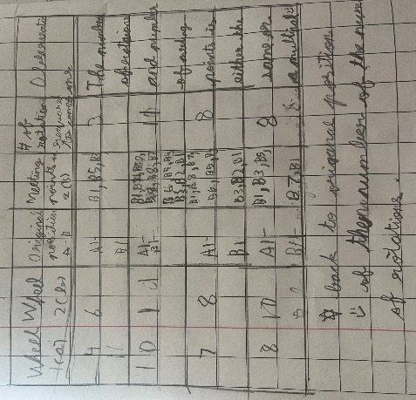
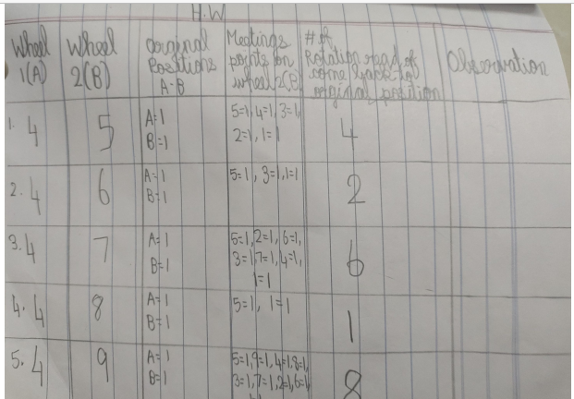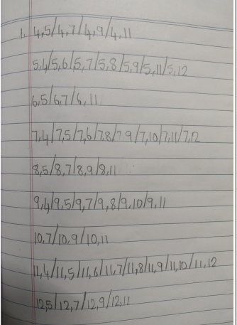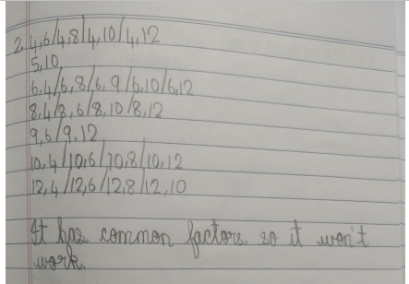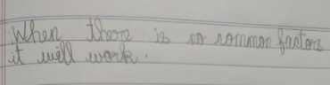
This is Pranathi’s work.
Vivaan shared his printed sheet as described earlier.
Utkarsh’s work:
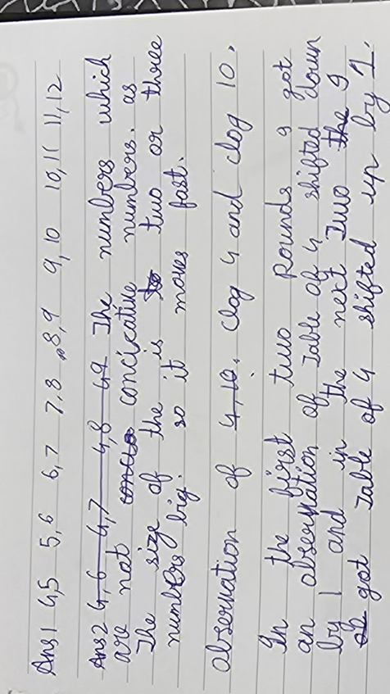

Utkarsh’ work shows how he has connected this task with Times table Shift taken earlier.

