The first step to solving this problem is to figure out the pattern. I did this by listing out the numbers that lit up starting at 0. For the green light bulb I wrote out 0,10,20,30… It was clear that the pattern could be represented in a linear function; in this case the function would be y = 10x. Repeat this 3 more times to get the 4 other bulbs functions. After I had the 4 equations I immediately thought to plot in in a graph as it would help me visualize the pattern and it looked something like this The lights light up at the whole number intersections.

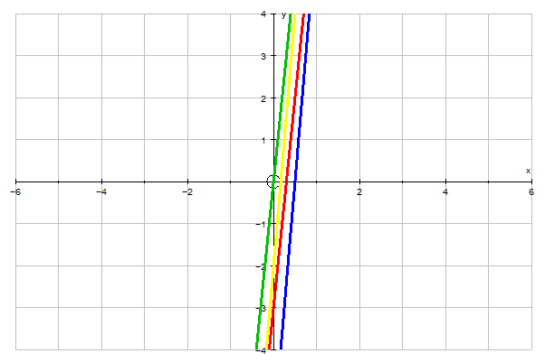
But this representation is problematic as it is unclear when the lights light up. It did shed some light (pun intended) on when lines cannot cross. In the graph above 2 lines have the same slope, but crossed the y axis at a different time so they were parallel.

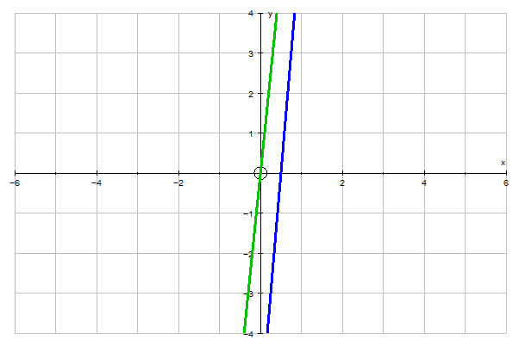
It was hard to go any further with this representation as it eventhough it express the green lights pattern as y = 10x it could be expressed as y = 10x - 10, y = 10x + 10,... So I used excel to make a table that look like this…
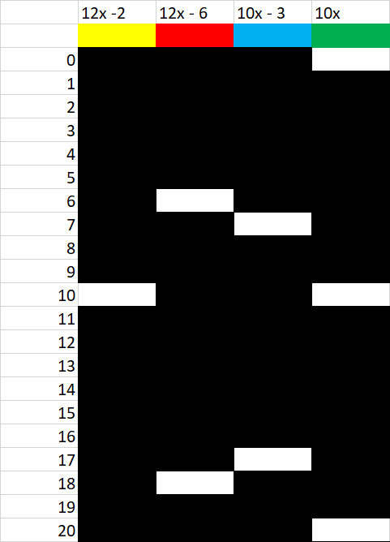
Every white space is when the light is on and every black space is when the light is off. So when 2 spaces are white in the same row they light up together. This picture only goes to 20 rows on the spreadsheet each row goes to 386 spaces and I will attach the full excel spreadsheet so you can check out the full table as well as some others I made.

From this table we can tell that blue and green will never light up together because they are parallel this can also apply to the yellow light and the red light.

From this table we can tell that the red and blue light will never light up together. I know this because the first positive integer for the red light is 6 and the slope is 12 and because anytime you add an even number to an even number you get an even number. (even + even = even) So the red light can only light up at even numbers. The blue light can only light up on odd numbers because the first positive integer is 7 and the slope is ten. Anytime you add an even number to an odd number you get an odd number (even + odd = odd). So the blue light will alway end up on odd. Finally because red will always light up on even numbers and blue will always light up on odd they can never light up together. Using this rule we can tell that blue and yellow will never light up together because yellow lights up on even and blue lights up at odd.
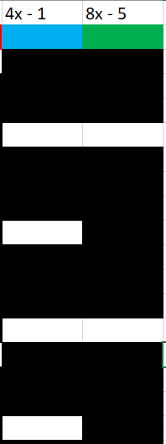
Now when attempting to find out when lights light up together I started by finding the GCF of the slopes In the case of what you see on the right the GCF of the 2 slopes is 8, now we need to find the y intercept for this equation. Now we come back to how we could right this equation as 8x - 5 or 8x - 13 or 8x - 21. To find the y intercept of this line we weed to find when the 2 intercepts meet. In this case it is easy because 4x - 1 can be rewritten as 4x - 5 and we don’t have to rewrite the 2nd equation. Now that we know that the y intercept is -5 and the slope is 8 we can combine them to say that the equation for the blue and green lights to light up together 8x - 5.

This also happens to be the equation of the green light so the blue light will always light up with the green light.

This method also works for finding 3 lights
Example
Yellow = 7x - 5
Blue = 5x - 1
Green = 4x

Yellow Blue Green = 140x + 144

